JOINT MEETING OF THE CHARLOTTE COUNTY- PUNTA GORDA MPO BICYCLE PEDESTRIAN ADVISORY COMMITTEE (BPAC) AND LEE COUNTY MPO BICYCLE PEDESTRIAN COORDINATING COMMITTEE (BPCC)

Burnt Store Presbyterian Church
11330 Burnt Store Rd, Punta Gorda, Florida 33955 November 22, 2016

LEE COUNTY MPO BPCC AGENDA - 9:45 AM
Call to Order
Pledge of Allegiance Roll Call
L1. *Endorsement of School District Priorities for SRTS Projects in Lee County
*Action Items +May Require Action

LEE COUNTY/CHARLOTTE CO. - PUNTA GORDA MPO BPCC/BPAC AGENDA – 10:00 AM

- Call to Order/Roll Call
- Election of a Chairperson
- Approval of Agenda
- Presentation and Update on the Babcock Development
- SUN Trail Network
- Burnt Store Road Trail and Capacity Improvement Status Report
- Presentation on the TIGER funded Lee County Complete Streets Initiative
- Presentation on City of Punta Gorda’s Bike Sharing Program
- Florida Department of Transportation (FDOT) Report
- Staff Comments
- Members’ Comments
- Public Comments
- Adjournment of Meeting

All interested parties are invited to appear and be heard on each of the above items. Written comments filed with the MPO will be considered. Copies of all of the above proposed documents are available by calling the Lee MPO Office at 239-244-2220 or the Charlotte County-Punta Gorda MPO Office at 941-883-3535.

THIS NOTICE is published pursuant to the requirements of the Federal Laws, Florida Statutes and MPO Policy. NO STENOGRAPHIC RECORD BY A CERTIFIED COURT REPORTER IS MADE OF THIS MEETING. ACCORDINGLY, ANY PERSON WHO MAY SEEK TO APPEAL ANY DECISIONS INVOLVING THE MATTER NOTICED HEREIN WILL BE RESPONSIBLE FOR MAKING A VERBATIM RECORD OF THE TESTIMONY AND EVIDENCE AT THIS MEETING UPON WHICH ANY APPEAR IS TO BE BASED.

Public participation is solicited without regard to race, color, national origin, age, sex, religion, disability, or family status. Persons who require special accommodations under the Americans with Disabilities Act or persons who require translation services (free of charge) should contact the Lee MPO at 239-244-2220 or the Charlotte County-Punta Gorda MPO at 941-883-3535 at least seven (7) days prior to the meeting.

THE MPO’S PLANNING PROCESS IS CONDUCTED IN ACCORDANCE WITH TITLE VI OF THE CIVIL RIGHTS ACT OF 1964 AND RELATED STATUTES. ANY PERSON OR BENEFICIARY WHO BELIEVES HE/SHE HAS BEEN DISCRIMINATED AGAINST BECAUSE OF RACE, COLOR, RELIGION, SEX, AGE, NATIONAL ORIGIN, DISABILITY OR FAMILY STATUS MAY FILE A COMPLAINT WITH THE LEE MPO TITLE VI COORDINATOR JOHNNY LIMBAUGH AT (239) 244-2220 OR BY WRITING HIM AT P. O. Box 150045, CAPE CORAL, FLORIDA 33915 OR THE CHARLOTTE COUNTY-PUNTA GORDA MPO TITLE VI COORDINATOR WENDY W. SCOTT AT (941) 883- 3535 OR BY WRITING HER AT 25550 HARBOR VIEW ROAD, SUITE 4, PORT CHARLOTTE, FL 33980

Agenda Item L1 Lee County BPCC 11/22/2016

MPO ENDORSEMENT OF THE SAFE ROUTE TO SCHOOL PROPOSALS

Attachments: SRTS Project Location Maps for Harns Marsh Elementary & Middle School, Island Coast High School and Edison Elementary School; Maps of # of Students living within a radius of 2 miles and ¼ mile of these schools.

Action Item: Recommend MPO endorsement of Lee County School District Prioritized SRTS proposals

In response to FDOT’s call for proposals for Safe Routes to School (SRTS) infrastructure funds, the School District of Lee County is submitting 3 (three) project applications. Consistent with the Lee MPO SRTS process, the school district prioritized proposals will need to be endorsed by the MPO Board before the applications can be signed by MPO staff, and submitted to FDOT. The school district prioritized proposals are as follows:

Priority #1: The proposal calls for sidewalks that will benefit Harns Marsh Elementary & Middle located in Lehigh Acres. The proposed sidewalk is on the north side of 25th Street West from Unice Avenue North to Sunshine Boulevard North. Cost Estimate: $
Maintaining Agency: Lee County BOCC

Priority #2: The proposal calls for sidewalks that will benefit Island Coast High located in Cape Coral. The proposed sidewalks are on both sides of Averill Boulevard from Del Prado Boulevard to Gator Circle South and along the perimeters of South Gator Circle. Cost Estimate: $
Maintaining Agency: City of Cape Coral

Priority #3: The proposal calls for sidewalks that will benefit Edison Park Elementary located in Fort Myers. The proposed sidewalks are on the west side of Clifford Street from Edison Avenue to Victoria Street. Cost Estimate:
$

Maintaining Agency: City of Fort Myers

Project location maps for each proposal are attached. The school district is finishing up the applications that go along with each proposal. All 3 proposals have been already been vetted by the BPCC when they were submitted unsuccessfully in previous years for either TA or SU funds.
At the November 22nd meeting, the Lee County BPCC will be asked to recommend MPO endorsement of the prioritized proposals. Applications are due to FDOT by December 31st.

ATTACHMENT A - Location Maps

Harns Marsh Elementary & Harns Marsh Middle
31ST ST W
TENA AVE N
RITA AVE N
RUTH AVE N

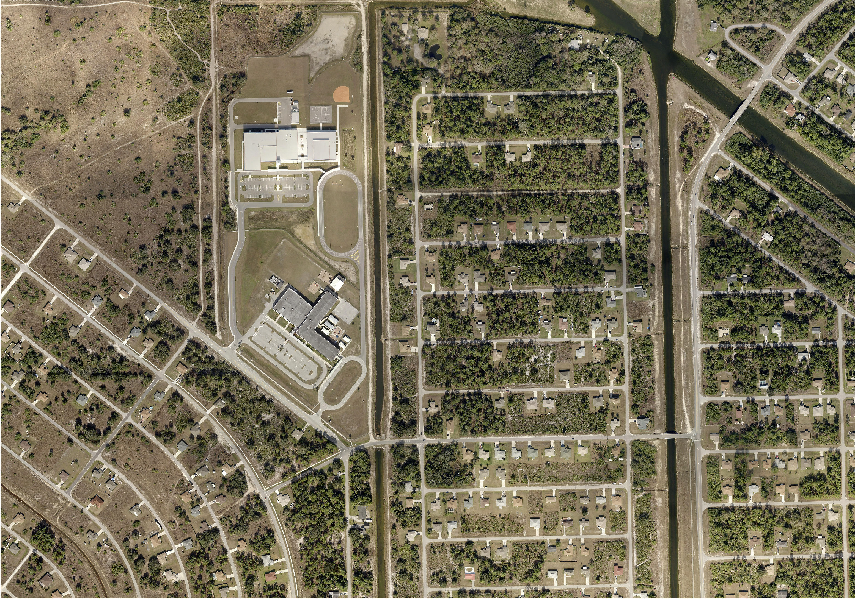

Map By: Dawn Huff Planning, Growth & School Capacity
23RD ST W
22ND ST W
SUNSHINE BLVD N

Date: 10/13/2014

Harns Marsh Elementary & Middle 2014-2015

Sidewalk on the north side of 25th St W from Unice Ave N to Sunshine Blvd N
Ü

46TH ST W
46
TH ST W
JACKSON RD
LAURA AVE N
45TH ST W 4 W
6TH ST

44TH ST W
W 15TH ST
44TH ST W
45TH ST W

43RD ST W 4 W
ND ST W
4TH ST
BARKWOOD ST
43RD ST W

42

41ST ST W

41ST ST W
40TH
IDA AVE N
43RD ST W
42ND ST W
CONGRESS AVE
CLARK AVE

ACACIA AVE

39TH ST W
ARBOR AVE
OLIVE AVE N
38TH
ST W
PINE ST
RUTH AVE N

36TH
35TH
TERRY AVE N
34TH ST W
CAMPUS ST

ST W ST W
41ST ST W
40TH ST W
39TH ST W
JUNE AVE N
38TH ST W
37TH ST W
36TH ST W
35TH ST W
ST W 39TH ST W
41ST ST W
40TH ST W
W 14TH ST
LEE AVE
PINE AVE
STATE AVE
39TH ST W
DIXIE AVE

CENTER ST
CHANCELLOR ST
HOMESTEAD RD
GENE AVE N
FLORA AVE N
ELAINE AVE N
DORA AVE N
CONNIE AVE N
BETH AVE N ANITA AVE N
WAGNER AVE
OAK AVE
RUSH AVE
33 | RD ST W
32ND ST W

W 12TH ST
31ST ST W
IDA AVE N

28TH
ST W
W 11TH ST
26TH ST W 27TH ST W
25TH ST W
TENA AVE N
RITA AVE N
NORA AVE N MABLE AVE N
LAURA AVE N
IRMA AVE N
CONNIE AVE N
ANN AVE N LEE AVE
PINE AVE
CONGRESS AVE
ACACIA AVE

BILLINGS ST

BELROSE ST BENTON ST

BARON ST
BALMER ST

22ND ST W
24TH ST W
23RD ST W
24TH ST W
OAK AVE
21ST ST W
20TH ST W
SUNSET RD
18TH ST W
18TH ST W
17TH ST W

Harns Marsh Elementary & Harns Marsh Middle
22ND ST W
21ST ST W
19TH ST W
W

18TH ST W
17TH ST W

W 10TH ST
22ND ST W
21ST ST W

W 9TH ST

17TH ST W
19TH ST W
18TH ST W
HANNA AVE N
FLORA AVE N ELAINE AVE N
WAGNER AVE
DIXIE AVE
RUSH AVE
STATE AVE
CLARK AVE

BUTTE ST
CHAUNCEY AVE
CORNELL AVE N
VARSITY CIR

ORDNANCE RD
OLIVE AVE N
17TH ST W
17TH ST W
18TH ST

16TH ST W
DENIS AVE N

16TH ST W

16TH ST W
20TH ST W

16TH ST W
16TH ST W
15TH ST W

ST W
BRUCE AVE N
VENICE AVE N
15TH ST W
14T
H ST W
UNICE AVE N
15TH ST W 15TH ST W
14TH ST W 14TH ST W
15TH ST W

14TH ST W

11TH ST W
CHAMPION AVE JAMES AVE N
JACK AVE N
FLOYD AVE N
10TH ST W

12TH ST W

11TH
14TH
13TH ST W
11TH
ST W
13TH ST W
13TH ST W 13TH ST W
TENA AVE N
SUSAN AVE N
SALLY AVE N SARA AVE N
11TH ST W
ST W
11TH ST W
10TH ST W

12TH ST W
11TH ST W
15TH ST W
14TH ST W
13TH ST W
12TH ST W
11TH ST W
9TH ST W
10TH ST W
9TH ST W
8TH ST W
7TH ST W
ELVA PL
JOAN AVE N
CONNIE AVE N

9TH ST W
COLIN AVE N
9TH ST W
10TH ST W
10TH ST W
9TH ST W

9TH ST W
7TH ST W
6TH ST W
7TH ST W
6TH ST W
5TH ST W

7TH ST W
6TH ST W
9TH ST W

7TH ST W
6TH ST W

5TH ST W
9TH ST W 8TH ST W
7TH ST W
8TH ST W
7TH ST W
6TH ST W
6TH ST W
5TH ST W
5TH ST W
4TH ST W

LEE BLVD

4TH ST W
4TH ST W
3RD ST W
IVAN AVE N
IRVING AVE N
HARRY AVE N HAROLD AVE N
GORDON AVE N
GERALD AVE N
FLOYD AVE N
DOUGLAS AVE N
DOUGLAS AVE N
CURTIS AVE N DENIS AVE S
COLIN AVE S CLYDE AVE S
BRIAN AVE N
BRUCE AVE N
ALAN AVE S
YVONNE AVE N

3RD ST W
3RD ST W
2ND ST W

4TH ST W
3RD ST W
2ND ST W
RITA AVE S

2ND ST W

3RD ST W
1ST ST W
ELVA AVE N
NWOOD AVE S

DOUGLAS LN

1ST ST SW

1ST ST SW

1ST ST SW

1ST ST SW

1ST ST SW
KIMDALE ST E

2ND ST SW 3RD ST SW
S I
2ND ST SW
3RD ST SW
3RD ST SW

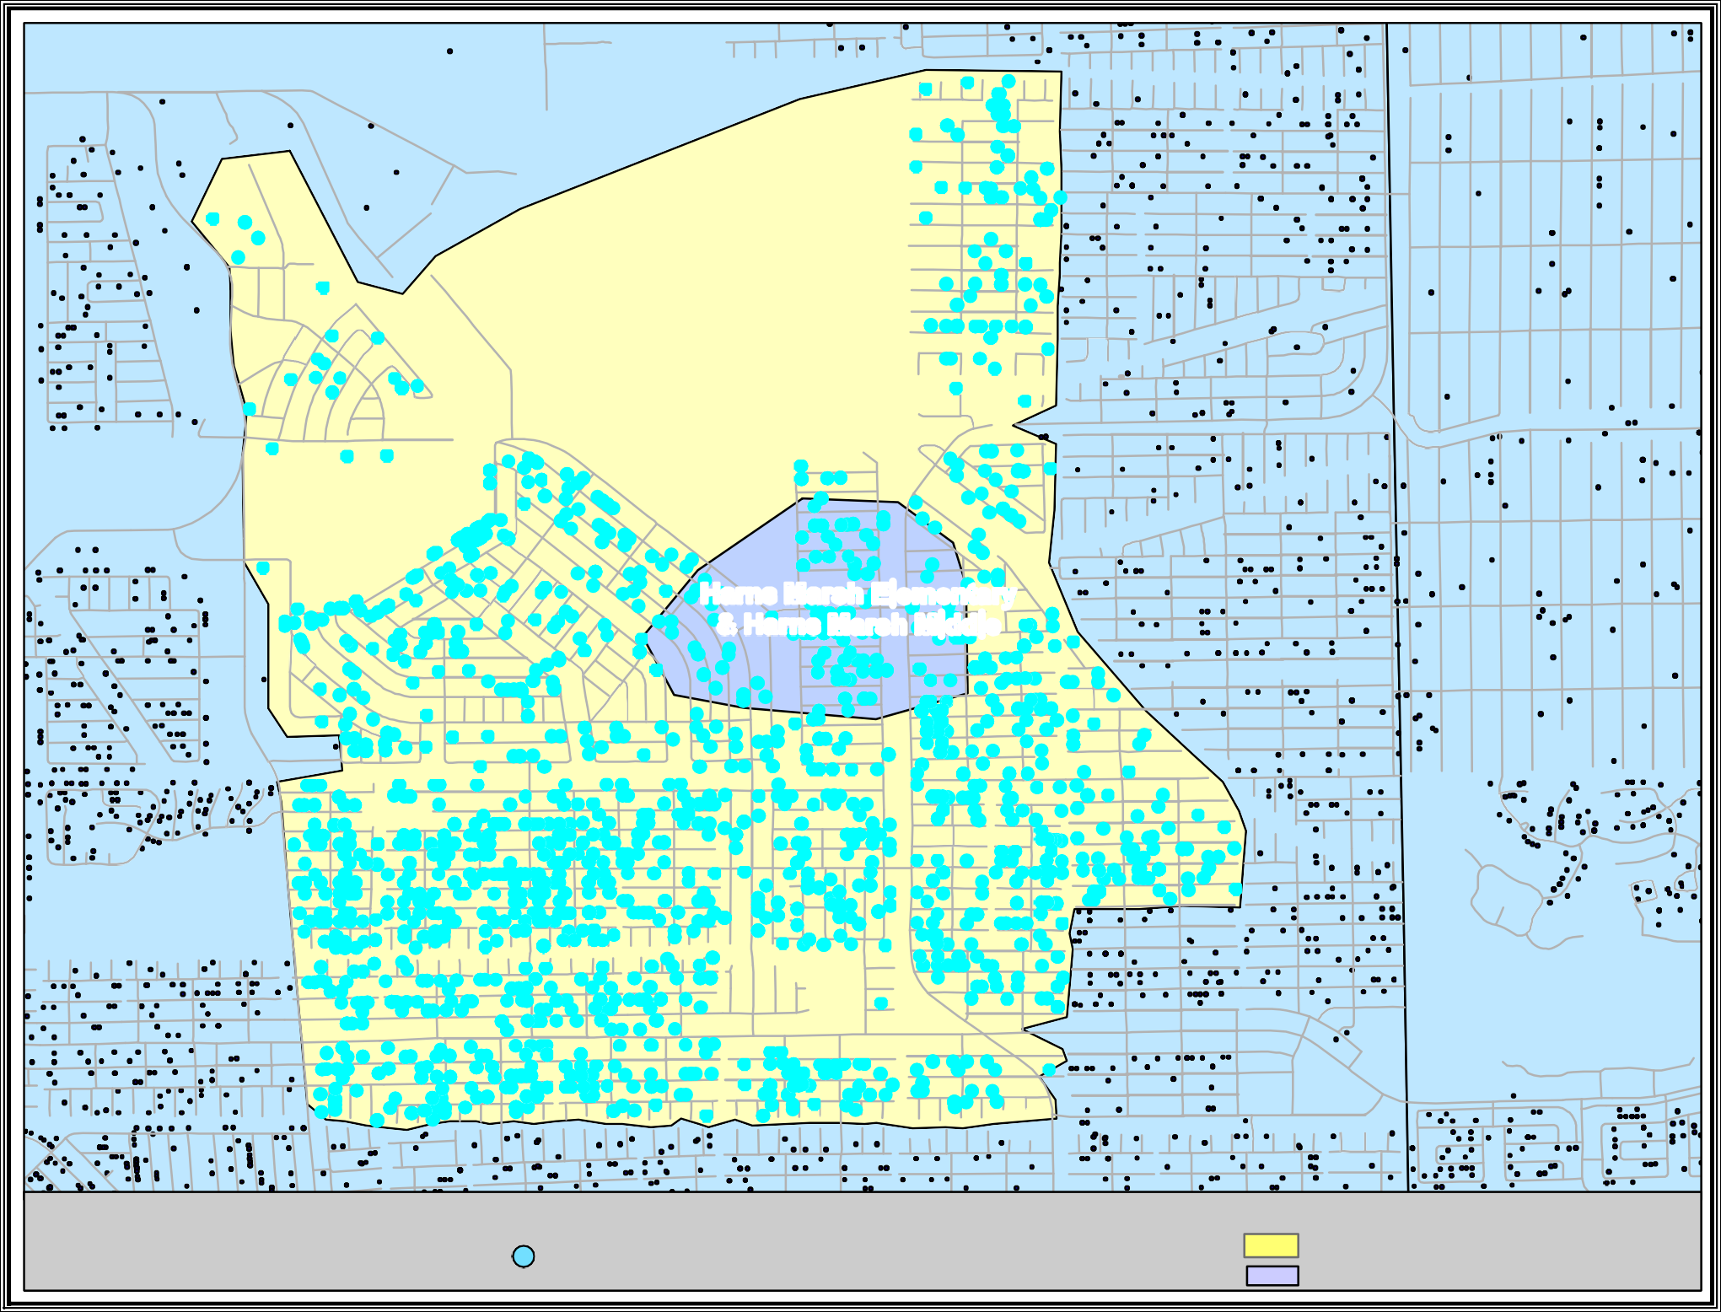

Map By: Dawn Huff Planning, Growth & School Capacity

Date: 10/13/2014

Harns Marsh Elementary & Middle 2014-2015
321 Students live and attend within 2 miles (2,389 total students) 59 Students live and attend within 1/4 mile (188 total students)
Ü

NE 41ST ST
ANDALUSIA BLVD
NE 8TH PL
NE 9TH AVE
NE 9TH PL
NE 10TH AVE
NE 10TH PL
NE 17TH AVE
NE 18TH AVE

NE 40TH ST
NE 8TH PL
NE 9TH AVE
NE 21ST PL
NE 23RD PL
GARDEN BLVD

NE 39TH TER
NE 39TH ST

NE 38TH TER

Island Coast

NE 37TH ST
NE 19TH PL
EAST GATOR CIR
NE 23RD PL

NE 36TH LN
WEST GATOR CIR

NE 36TH TER
NE 9TH AVE
NE 12TH AVE
NE 12TH PL
NE 12TH CT
NE 36TH LN NE 36TH TER
NE 36TH LN

EAGLE VIEW LN

NE 34TH LN
NE 8TH PL
NE 9TH AVE
NE 36TH ST

NE 35TH LN
NE 10TH AVE
NE 10TH PL

NE 34TH TER
NE 34TH TER

NE 34TH ST NE 33RD LN
NE 9TH PL
NE 33RD TER NE 33RD ST NE 32ND LN
NE 36TH ST

NE 35TH LN NE 35TH TER
NE 14TH PL
NE 15TH AVE
NE 17TH AVE
NE 17TH PL
NE 18TH AVE
NE 18TH PL
NE 19TH AVE
NE 20TH PL
NE 21ST AVE
NE 35TH ST

NE 34TH LN SOUTH GATOR CIR
AVERILL BLVD
NE 19TH PL
NE 21ST AVE
NE 34TH ST NE 33RD LN
NE 13TH PL
NE 15TH PL
NE 33RD TER
NE 33RD TER
NE 18TH PL
NE 20TH PL

NE 33RD ST NE 32ND LN
NE 36TH ST NE 35TH LN
NE 35TH TER NE 35TH ST NE 34TH LN
NE 21ST PL
DANDOLO CIR
MALAGROTTA CIR
NE 34TH TER NE 34TH ST NE 33RD LN
NE 23RD PL
NE 33RD TER DEL PRADO BLVD N

Map By: Dawn Huff Planning, Growth &
NE 32ND TER
NE 32ND ST

Sidewalk Along Perimeters of Gator Circle

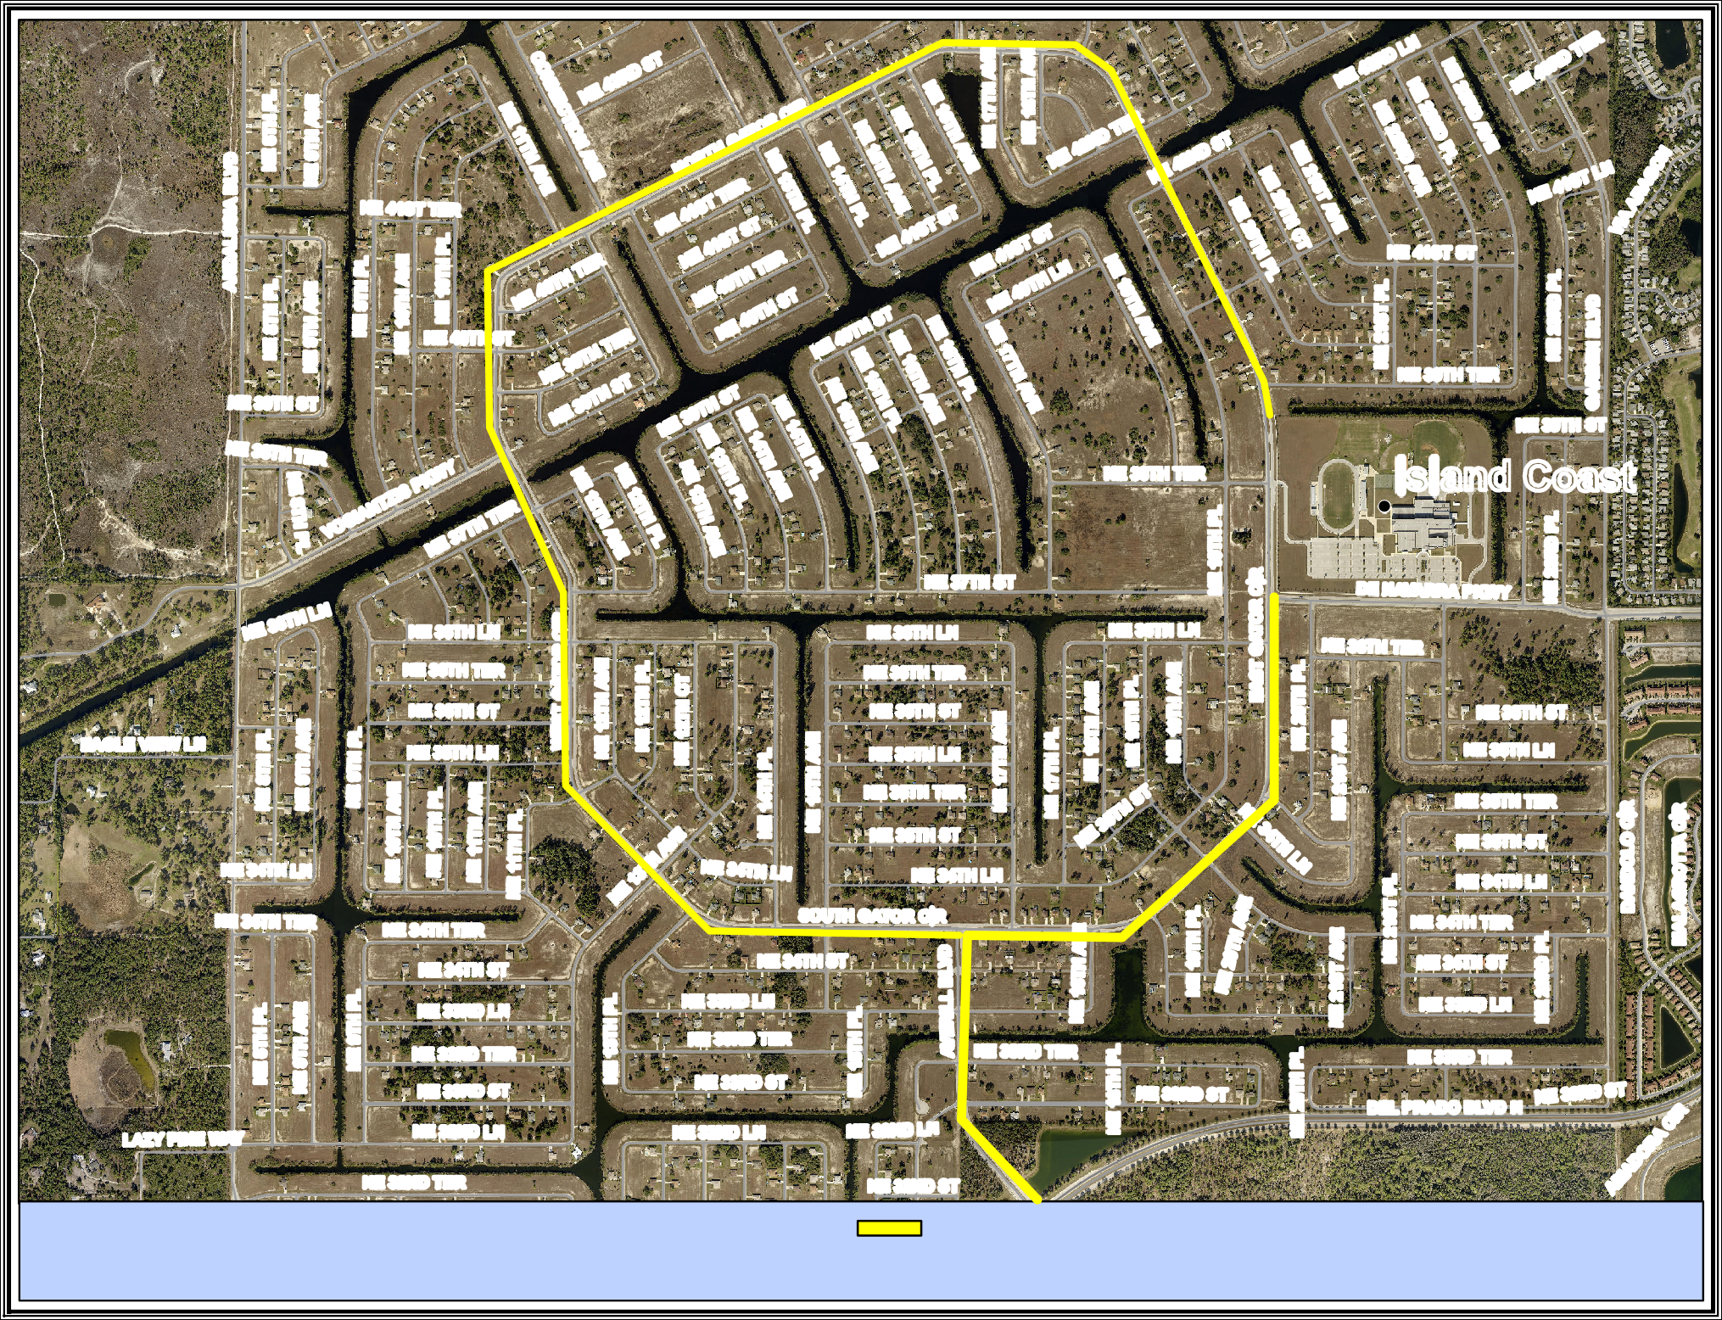
Date: 10/17/2016 Island Coast High
School Capacity

and Averill Blvd

DURDEN PKWY

NE 44TH LN
CARAVAN CIR
GRESHAM LN
ANDALUSIA BLVD
NE 8TH PL
NE 9TH AVE

NE 38TH TER
NE 8TH PL
NE 8TH PL
NE 10TH AVE
NE 10TH PL
NE 40TH ST NE 39TH TER

Island Coast
GARDEN BLVD

IRONSTONE DR
EAGLE VIEW LN

EAGLE RD

NE 36TH LN NE 36TH TER NE 36TH ST

NE 34TH ST NE 33RD LN
NE 34TH TER
NE 8TH PL NE 9TH AVE
NE 9TH PL
NE 10TH PL
WEST GATOR CIR NE 12TH AVE
NE 12TH PL
NE 12TH CT

NE 33RD LN
NE 13TH PL
NE 37TH ST
NE 36TH LN NE 36TH TER NE 36TH ST
NE 14TH PL
NE 15TH AVE
NE 17TH PL
NE 18TH AVE
NE 35TH LN NE 35TH TER
NE 35TH ST
NE 34TH LN SOUTH GATOR CIR NE 34TH ST

DE NAVARRA PKWY

NE 36TH ST NE 35TH LN
LAURENTINA LN
NE 19TH PL EAST GATOR CIR
NE 20TH PL
NE 21ST AVE
NE 21ST PL
DANDOLO CIR
NE 35TH TER NE 35TH ST NE 34TH LN NE 34TH TER
NE 21ST PL
NE 34TH ST NE 33RD LN
NE 33RD TER
NE 33RD ST

JACARANDA PKWY E NE 31ST TER
NE 33RD TER NE 33RD ST
NE 32ND LN
NE 13TH AVE
NE 13TH PL NE 13TH CT NE 14TH AVE NE 14TH PL NE 14TH CT
NE 15TH AVE
NE 32ND TER NE 32ND ST
NE 33RD TER
NE 33RD ST

NE 32ND ST
NE 33RD TER DEL PRADO BLVD N

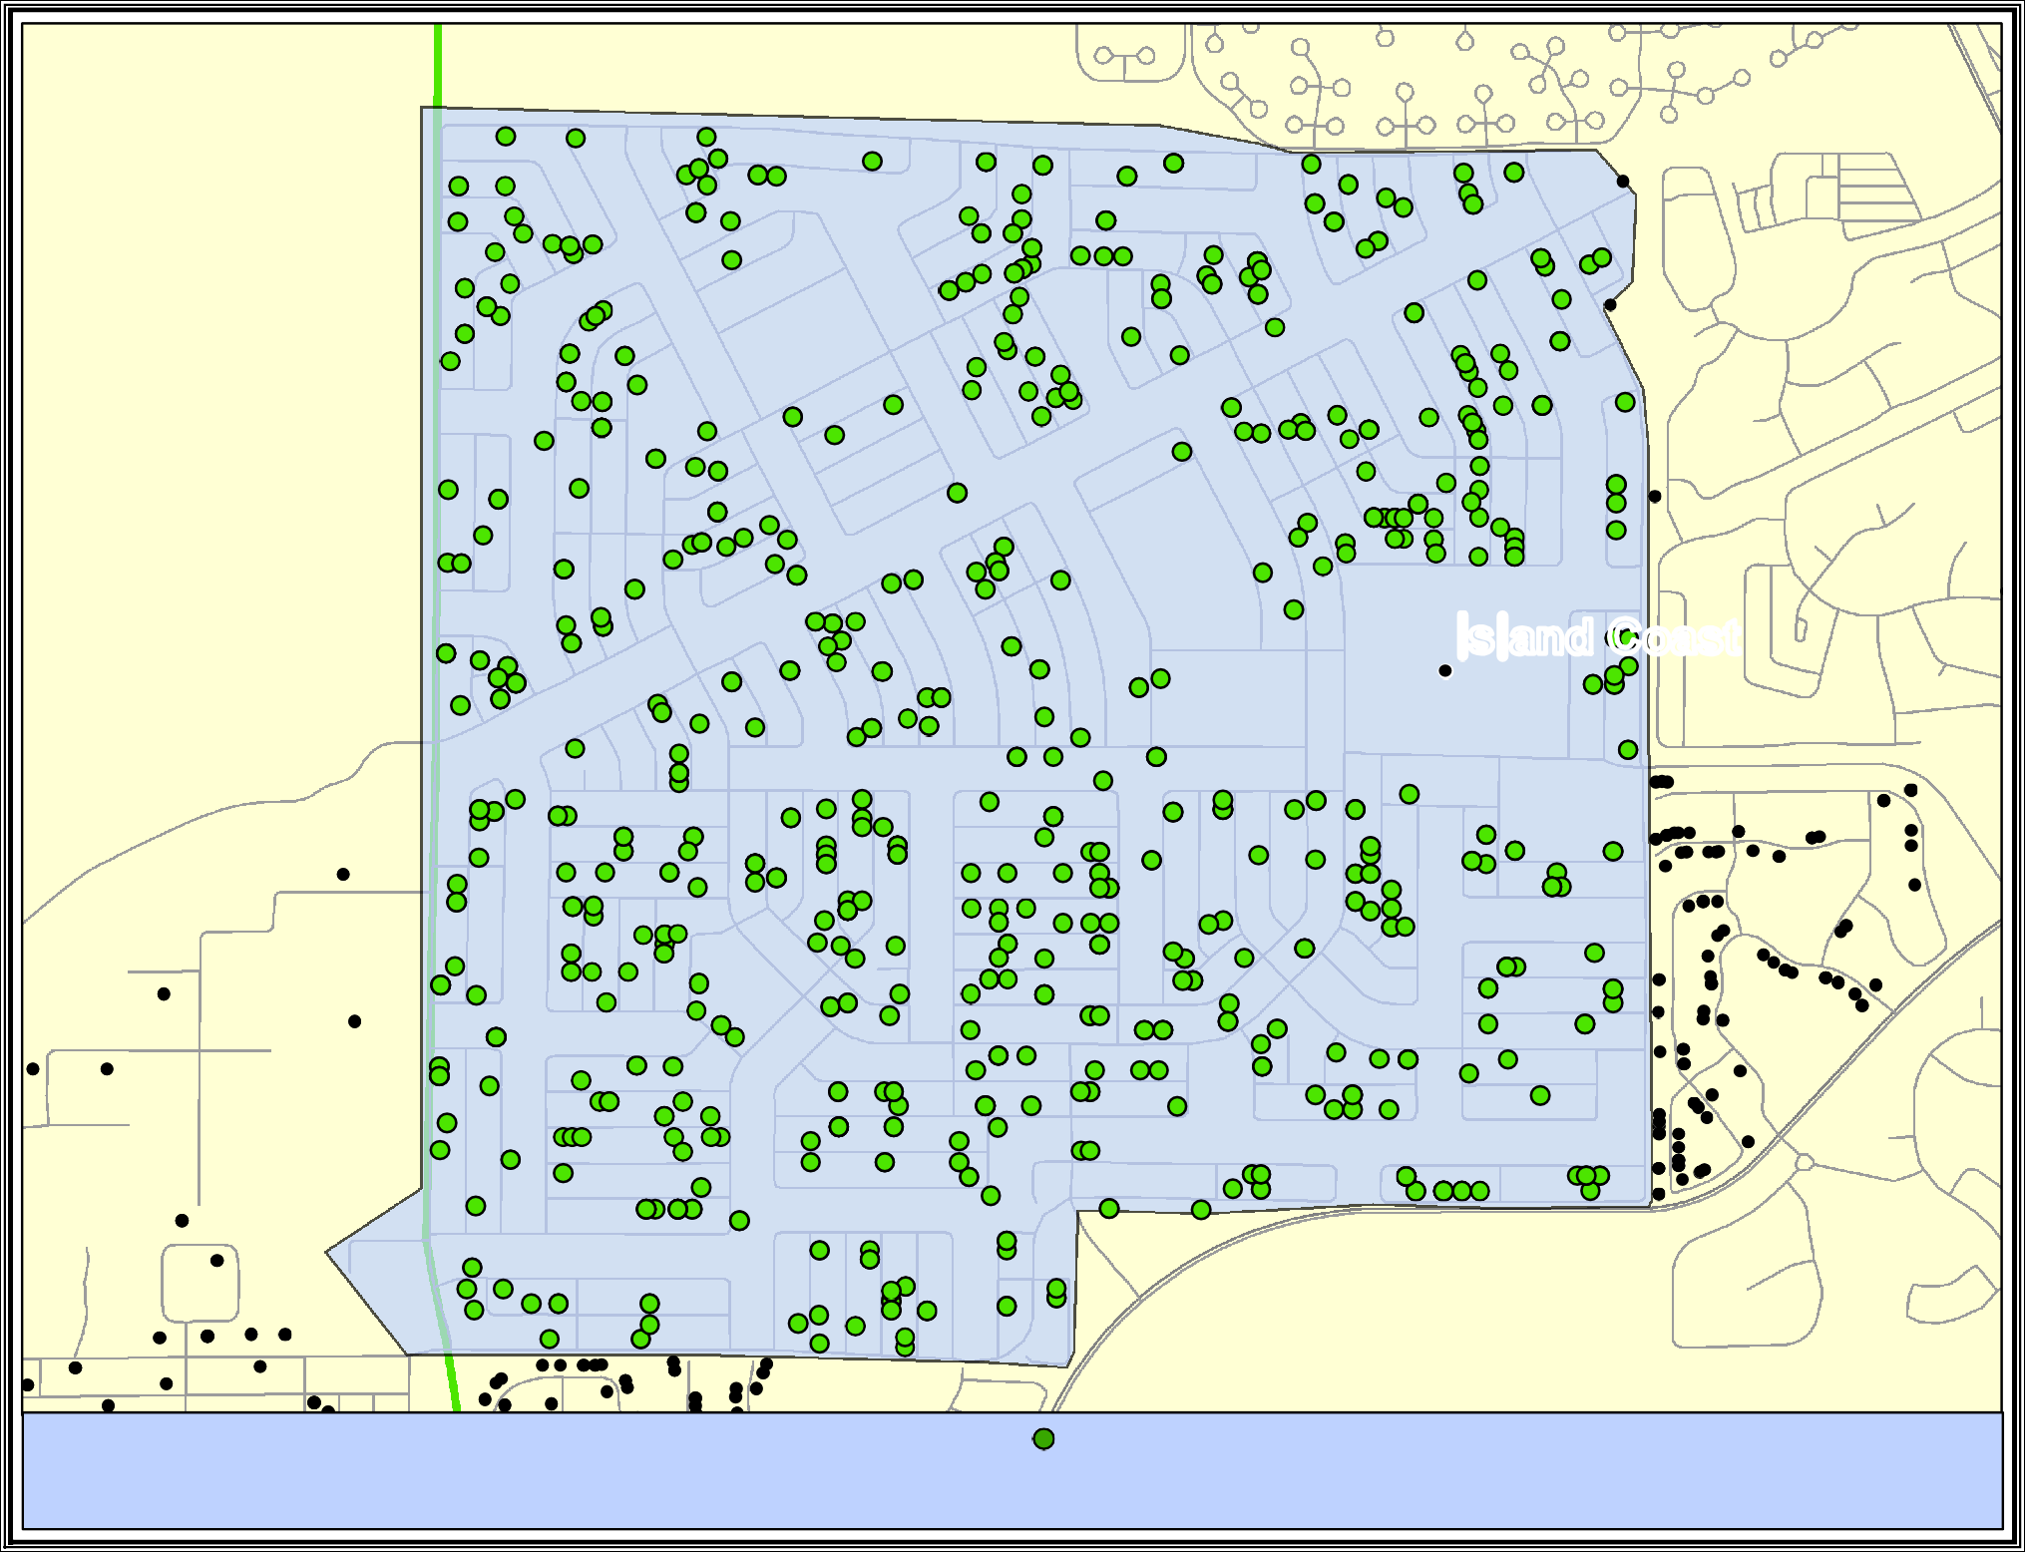
RAMSEY BLVD

Map By: Dawn Huff Planning, Growth & School Capacity

Date: 10/17/2016

Island Coast High

Number of students within 2 miles Live within 846
Live and attend 95

VICTORIA AVE

CRAWFORD ST
EUCLID AVE
ALTAMONT AVE
CLIFFORD ST
FOREST ST
GRAND AVE

LAFAYETTE ST

LAFAYETTE ST
CLEVELAND AVE
CLEVELAND AVE

Edison Park Elementary

EDISON AVE

Map By: Dawn Huff Planning, Growth & School Capacity
NT R
EUCLID AVE

Edison Park Elementary 2014-2015 Ü

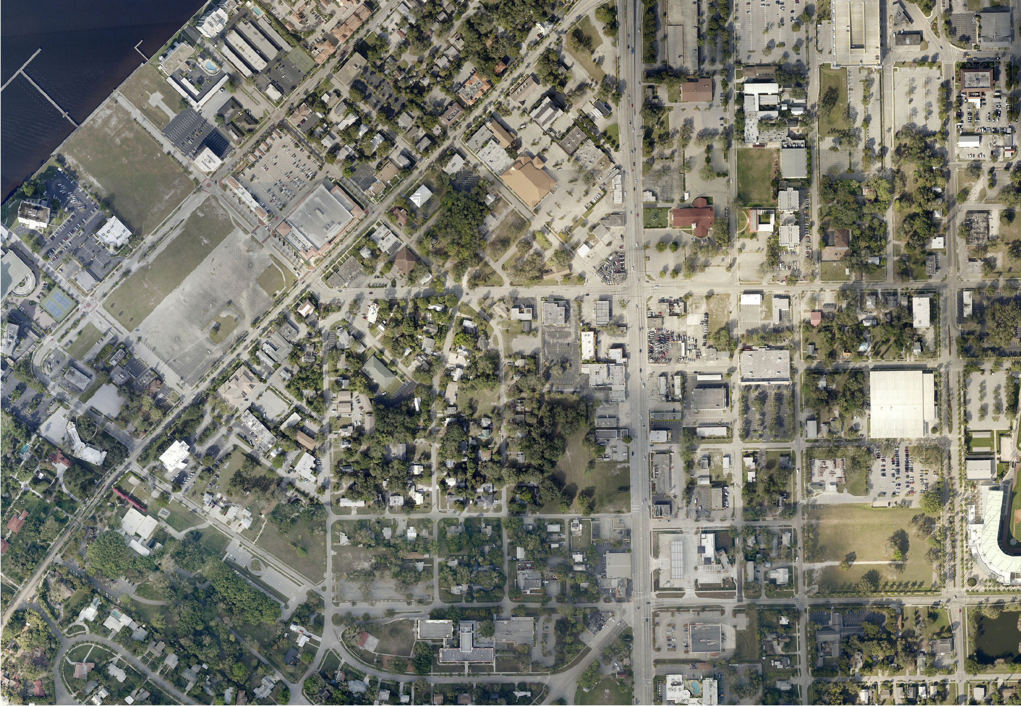Date: 10/13/2014 Sidewalk on west side of Clifford St from Edison Ave to Victoria St.
LIBERTY ST
CALOOSAHATCHEE BRIDGE
HEITMAN ST
COTTAGE ST
MONROE ST

PROVIDENCE ST
MICHIGAN AVE

GUAVA ST
DR ELLA PIPER WAY
LIME ST
ORANGE ST
EVANS AVE
PALM AVE

LARMIE ST
LEMON ST
DR MARTIN LUTHER KING JR BLVD
WIDMAN WAY
UNION ST
COTTAGE ST
MONROE ST
FOWLER ST
CRANFORD AVE

LIBERTY ST
LIBERTY ST
BLAKE ST
EVANS AVE

MARKET ST
VICTORIA AVE
CLIFFORD ST
FOREST ST
CLEVELAND AVE
CENTRAL AVE
FOWLER ST
ALICIA ST

ST CHARLES ST
HEITMAN ST
GRAND AVE
JACKSON ST
ROYAL PALM AVE

LAFAYETTE ST
EUCLID AVE
LAFAYETTE ST

Edison Park Elem
EVANS AVE

FRANKLIN ST
DORA ST

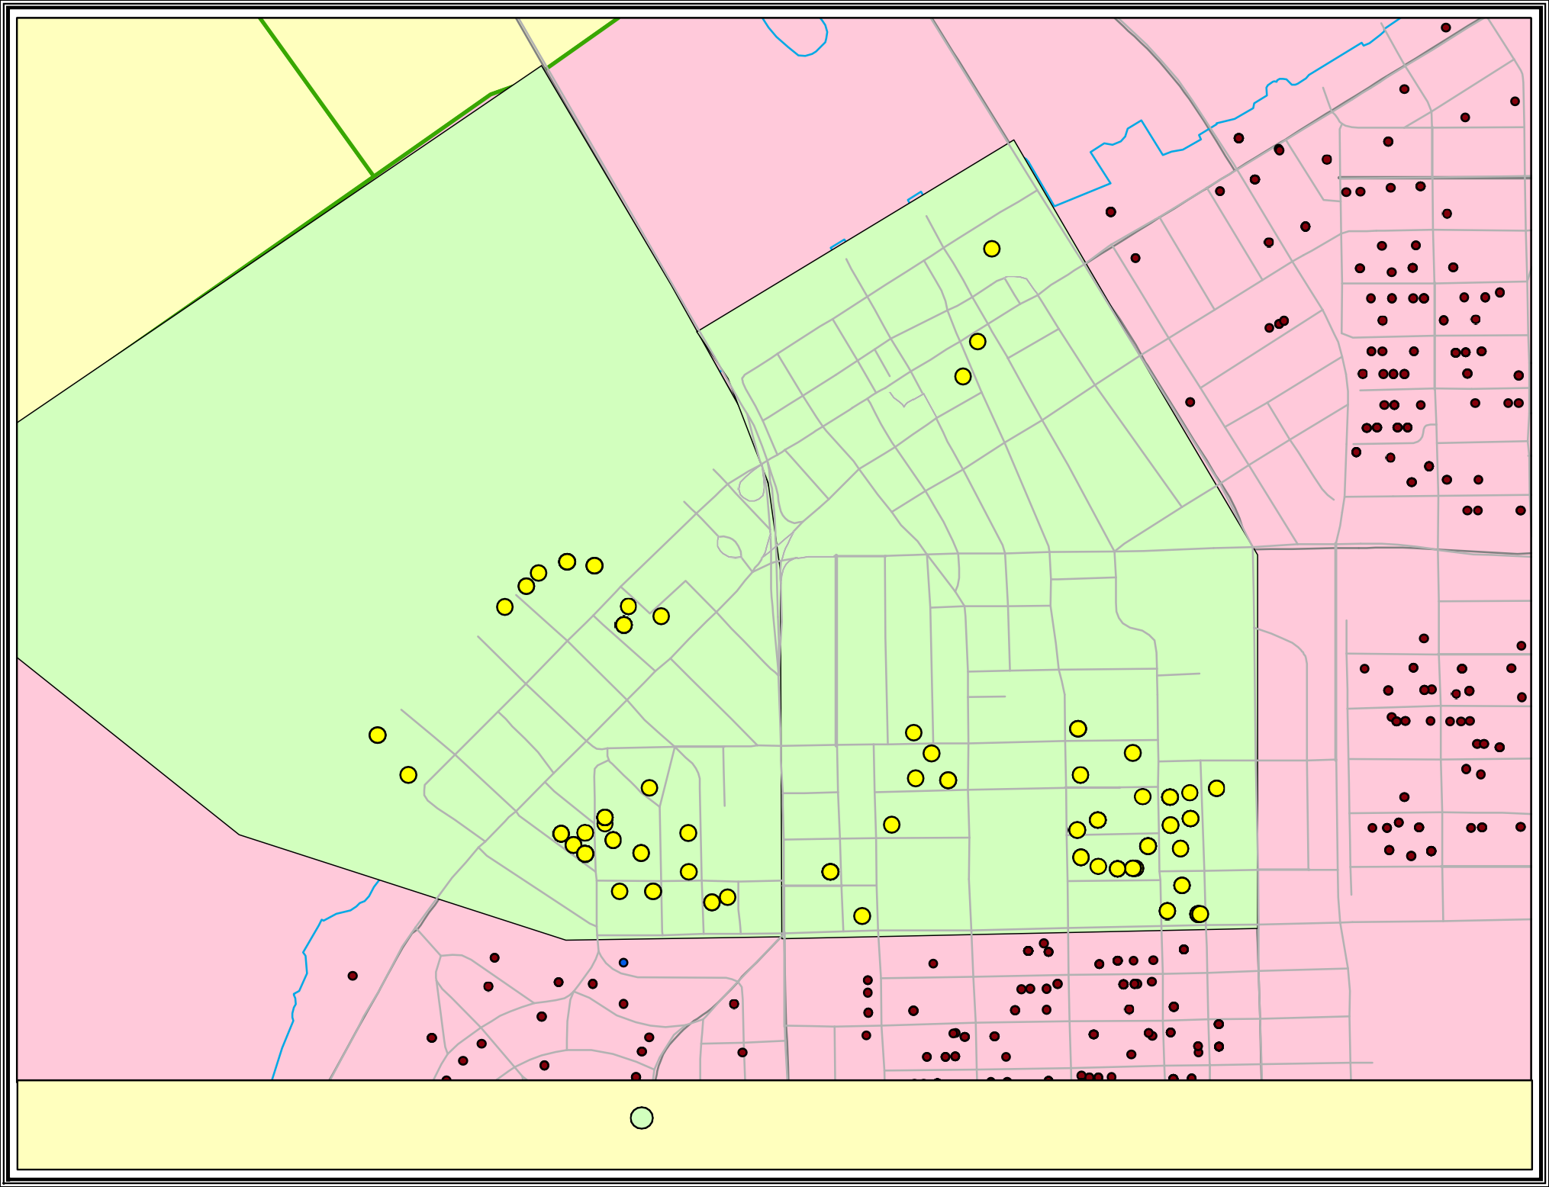

Map By: Dawn Huff Planning, Growth & School Capacity

Date: 3/29/2016

Edison Park Elementary

Students within 2 miles of walkable distance to proposed sidewalk 132 total students
6 attend Edison Park Elementary

Agenda Item 4 Joint Lee Charlotte County-Punta Gorda MPO 11/22/2016

PRESENTATION AND UPDATE ON THE BABCOCK DEVELOPMENT

Attachments: Map of Proposed Town of Babcock Ranch

Information Item: Status update on the Town of Babcock Ranch

At the joint BPCC/BPAC meeting on November 22nd, a team led by Kitson & Partners Communities will provide an update on the ongoing and planned development activities related to Babcock Ranch. This will also include a status of the roadway expansion studies on SR 31 including the Project Development and Environmental Study and the State Environmental Impact Report. Additional information on the development can be found on their website at www.babcockranchflorida.com.

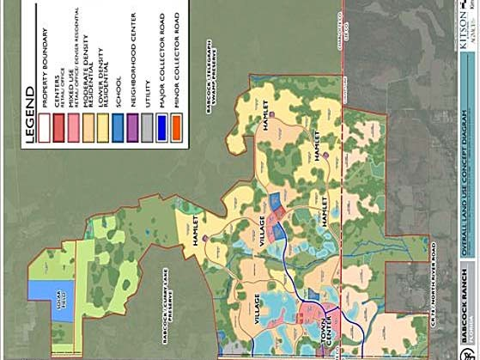

Agenda Item 5 Joint Lee Charlotte County-Punta Gorda BPCC/BPAC 11/22/16

SUN TRAIL NETWORK

Attachments: FDOT SUN Trail Network Map, and a Map of Conceptual
Babcock Ranch Trail Connections

Discussion Item: SUN Trail Funded Projects and Proposed SUN Trail
Network Expansion in Lee and Charlotte County

Background:

Two proposed trail segments in Charlotte County and two in Lee County received Shared Use Non-Motorized (SUN) Trail Program funds during the 2016 funding cycle. To qualify for SUN Trail funds, projects must be along trails identified in FDOT’s SUN Trail Network. There is $25 million available annually under this program with 2/3rd of the funds available for projects on the Coast to Coast Trail and the St. Johns River-To-Sea Loop (the top two regional trail corridors in the state), and 1/3rd of the funds available for individual trail projects. Attachment A includes the map of SUN Trail Network and individual trail projects.

The two (2) individual trail projects in Charlotte County that were awarded SUN Trail funds are as follows:

- A $1,114,000 construction phase in FY 2017 for the Harborwalk Phase 18 Southern Boardwalk (#35 in the Sun Trail Network Map).
- A $215,000 design phase in FY 2017 for the North Alligator Creek Pedestrian Bridge (#36 in the Sun Trail Network Map). A $1,564,000 construction phase in FY 2019 is also programmed in the Draft Tentative Work Program.

The one individual trail project in Lee County that was awarded SUN Trail funds is as follows:
- A $1,778,000 design phase in FY 2017 for a Multi-Use Trail on Van Buren Parkway from Burnt Store Road to El Dorado Parkway, El Dorado Parkway from Van Buren Parkway to Kismet Parkway and Kismet Parkway from El Dorado Parkway to Del Prado Boulevard (#37 on the Sun Trail Network Map). A $3,632,934 Phase I construction in FY 2019 is also programmed in the Draft Tentative Work Program.
- A $327,140 design phase FY 2017 extending John Yarborough Linear Park from its current northern terminus at Colonial Boulevard to Hanson Street. This project is not yet reflected on the SUN Trail Network Map.

Both Lee and Charlotte County-Punta Gorda MPOs are working to expand the SUN Trail Network in their respective counties so that more projects can qualify for SUN Trail funds in the future. The process requires the addition of new individual trails to the Office of Greenways and Trail’s (OGT) Priority Trails Map which would then automatically put them on the SUN Trail network. The Office of Greenways and Trails is currently soliciting input from the MPOs for updating its Priority Trails System Map and the schedule calls for approval of all changes in 2018.

Two regional trails that are being pursued for inclusion on the SUN Trail network by both our MPOs are the SR 31 Multi-Use Trail in Lee County, and the Babcock Webb Extension Trail in Charlotte County because of their common link to the Town of Babcock Ranch. Both trails will connect to the proposed multi-use trail within Babcock Ranch. Attachment B includes a map of these proposed trails.

ESCAMBIA

1

SANT A ROSA

OKAL OOSA

WA L T O N

HOLMES

W ASHINGT ON

BA Y

2

JACKSON

CALHOUN

LIBERT Y

GADSDEN

W AKULLA

3

LE ON

4

JEFFERSON

MADISON

HAMIL T O N

SUW ANNEE

C O L UMBIA

BAKER

UNION

NASSA U

DUV AL

50 Miles

GULF

FRANKLIN
T A YL OR

LAF A YET TE

GIL CHRIST

BRADFORD

ALACHU A

CLA Y

7
ST . JOHNS 8
10 9 12
13

DIXIE
6
LEV Y
PUTNAM

FLAGLER
14
11
15
23 16

Shared Use Nonmotorized (SUN) Trail Program

5 30

CITRUS

MARION

LAKE
24
26 21 17
VOL USIA
25 18

Florida Department of Transportation Systems Planning Office

HERNANDO
31

P ASC O
SUMTER

29

34
27 SEMINOLE 22 19
ORANGE 20
28

Regional Trail Systems and Individual Trail Projects Fiscal Year 2016/2017

33 HILLSBOROUGH
32
PINELLAS

POLK
BREV ARD
OSCE OLA

38
INDIAN RIVER 39

SUN Trail Network Coast to Coast Trail
St. Johns River-to-Sea Loop Trail Coast to Coast Project
St. Johns River-to-Sea Loop Project
FDOT District Boundaries
Strategic Intermodal System Highway County
Water

35

MANA TEE

SARASO T A

HARDEE

DESO T O

CHARL O T TE
40
HIGHLANDS
OKEE CHOBEE ST . L UCIE 41
42
MARTIN

GLADES

Individual Trail Project
36 37

LEE

HENDRY

P ALM BEACH

For more information, please visit www.FloridaSunTrail.com

BROW ARD

C OLLIER

43

MONROE

MIAMI - D ADE

44
45

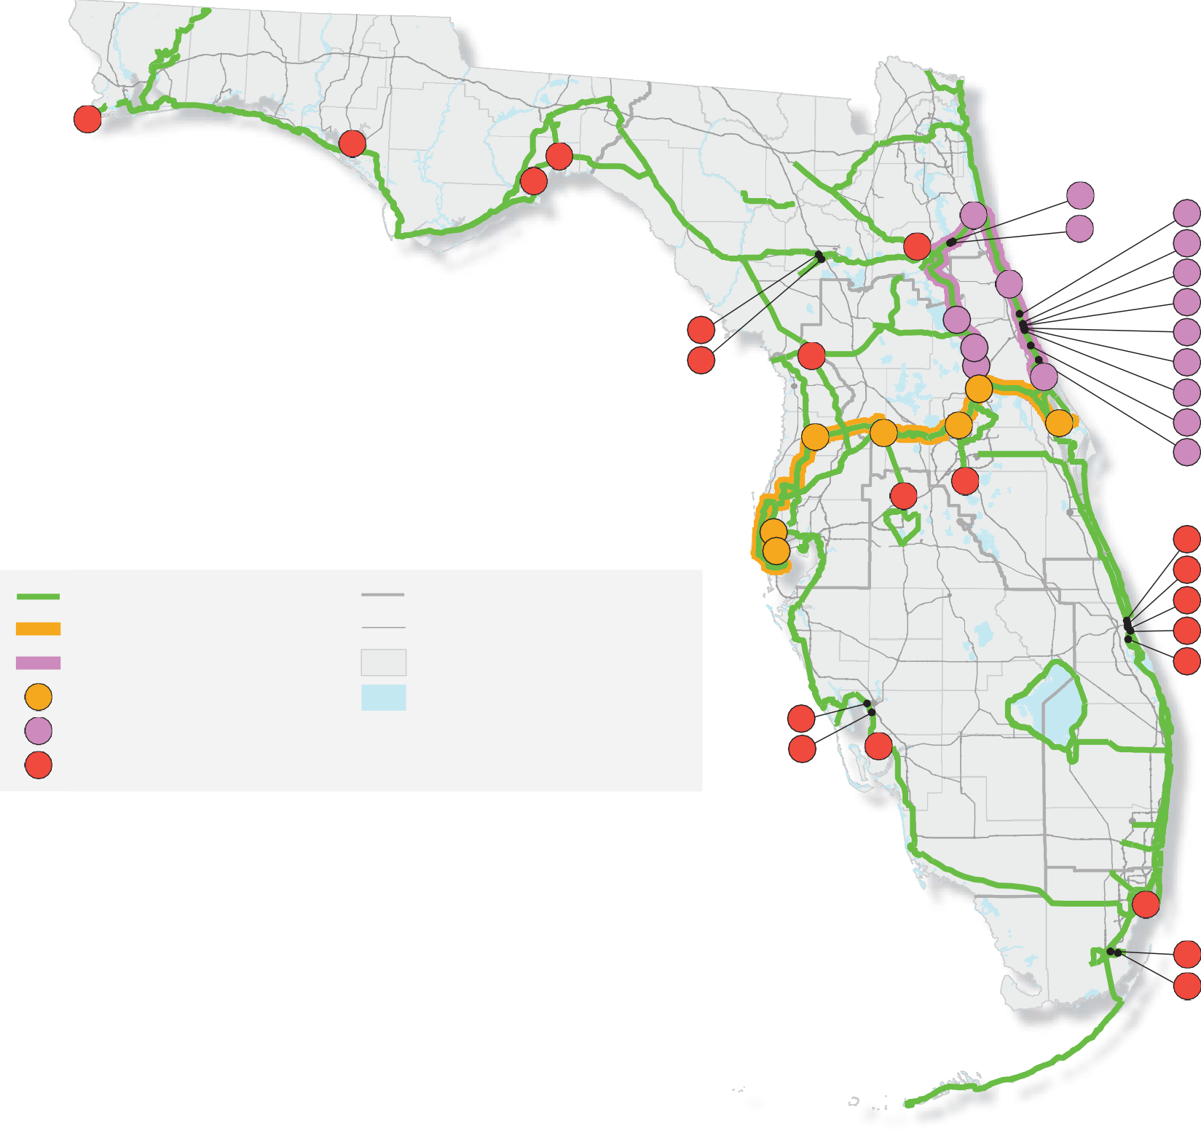

Shared Use Nonmotorized (SUN) Trail Program
Florida Department of Transportation Systems Planning Office

Regional Trail Systems and Individual Trail Projects - Fiscal Year 2016/2017

ID | Tier | FDOT  Dist. | Counties | Trail Name | Segment | Cost | Phase | FM  Number
1 | IND | 3 | Escambia | Perdido Key Multiuse Trail (SR 292) | Alabama State Line to State Park Entrance / Gongora Drive | $1,123,144 | PE | 4389082
2 | IND | 3 | Bay | Lynn Haven Rails to Trails | SR 75 (US 231) to East 10th Street | $268,000 | PE | 4399281
3 | IND | 3 | Wakulla | CC2S: Coastal Trail West: SR 30 (US 98) Coastal Highway | CR 372 / Surf Road to SR 61 (US 98) | $800,000 | PE | 4399261
4 | IND | 3 | Wakulla | CC2S: Coastal Trail East: SR 30 (US 98) | West of SR 363 Woodville Highway / St. Marks Trail to Lighthouse Road | $200,000 | PE | 4399262
5 | IND | 2 | Alachua | SR 24 / Archer Road Multiuse Trail | SW 76th Terrace to SW 41st Boulevard, Gainesville | $450,000 | PE | 4399341
6 | IND | 2 | Alachua | Tower Road Multiuse Trail | SW 26th Place to SW 8th Avenue, Gainesville | $950,000 | CON | 4399331
7 | IND | 2 | Putnam | Palatka to Lake Butler State Trail aka SR 100 Rail Trail | Roberts Lane to St. Johns River Water Management District | $6,261,419 | CON | 4282023
8 | SJR2C | 2 | St. Johns | Palatka to St. Augustine State Trail aka SR 207 Rail Trail | Putnam County Line to Hastings | $2,217,575 | CON | 4357961
9 | SJR2C | 2 | St. Johns | Palatka to St. Augustine State Trail aka SR 207 Rail Trail | Main St (Hastings) to SR 207 / Spuds | $3,288,834 | CON | 2102868
10 | SJR2C | 2 | St. Johns | SR 207 / A1A | End of trail to Flagler County Line | $750,000 | FS | 4399321
11 | SJR2C | 5 | Flagler | SR A1A | A1A or Alternate Route from S 26th Street to N 9th Street | $600,000 | FS, PDE | 4398731
12 | SJR2C | 5 | Volusia | Ormond Beach Gap | SR 40 from Cassen Park to A1A | $300,000 | FS | 4398721
13 | SJR2C | 5 | Volusia | Daytona Beach Gap 1: N Beach St | Sickler Drive from 350' south of 2nd Street to 2nd Street | $20,000 | PE | 4398711
14 | SJR2C | 5 | Volusia | Daytona Beach Gap 2: Ballough Bridge | Ballough Road Bridge approximately 0.01 miles north of Anita Avenue | $20,000 | PE | 4398701
15 | SJR2C | 5 | Volusia | Daytona Beach Gap 3: S Beach St | South Beach St from Marina Point Drive to Orange Avenue | $100,000 | PE | 4398691
16 | SJR2C | 5 | Volusia | Daytona Beach Gap 4: S Beach St | South Beach St from Bellevue Avenue to Marina Point Drive | $65,000 | PE | 4398681
17 | SJR2C | 5 | Volusia | Daytona Beach Gap 5: Donnelly Pl | Donnelly Place from Shady Place to Bellevue Ave | $510,000 | CON | 4398671
18 | SJR2C | 5 | Volusia | Daytona Beach Gap 6: S Beach St | South Beach St from Wilder Blvd to Shady Pl | $100,000 | PE | 4398661
19 | SJR2C | 5 | Volusia | New Smyrna to Port Orange Gap: US 1 | US 1 from Canal St to Beville Rd | $1,500,000 | PDE | 4398651
20 | SJR2C | 5 | Volusia | Edgewater Gap | Dale Ave to 10th St | $1,100,000 | CON | 4398631
21 | SJR2C | 5 | Volusia | Oak Hill to Edgewater: US 1 | US 1 at Kennedy Parkway to Dale Ave | $800,000 | PDE | 4398621
22 | C2C | 5 | Brevard | Space Coast Trail: Titusville | East end of Max Brewer Bridge to Merritt Island Refuge | $300,000 | PE | 4361873
23 | SJR2C | 5 | Volusia | Pierson Gap: SR 15 (US 17) | SR 15 (US 17) from Washington Ave to Palmetto Ave | $300,000 | PE | 4398771
24 | SJR2C | 5 | Volusia | Spring to Spring Gap: Deleon Springs | Grand Ave / Baxter St to SR 15 (US 17) | $750,000 | PE | 4398751
25 | C2C | 5 | Seminole/Volusia | Spring to Spring Trail: US 17 / 92 Bridge | Wayside Park to Lake Monroe Park | $1,800,000 | CON | 4364341
26 | SJR2C | 5 | Volusia | Spring to Spring Gap: Deland | Lake Beresford Park to Grand Ave | $750,000 | PDE | 4398741
27 | C2C | 5 | Orange | Orange Co Gap Segment 2 | N Hiawassee Rd to N of SR 414 on SR 441 / Clarcona | $2,000,000 | PE | 4364331
28 | IND | 5 | Osceola | Shingle Creek Trail South Phase 1B | Palmetto Ave to southern limit of future Shingle Creek Phase 2B | $2,230,000 | CON | 4398781
29 | C2C | 5 | Lake | South Lake Trail Phase 4 | Van Fleet State Trail to Villa City Rd (CR 565) | $700,000 | PE | 4358931
30 | IND | 7 | Citrus | HOFL: Withlacoochee-Dunnellon Trail Connector | North end of Withlacoochee State Trail to south end of Dunnellon Trail | $280,000 | PE | 4373491
31 | C2C | 7 | Hernando | Good Neighbor Trail Connector: Alternate Alignment | West Suncoast Parkway to SR 50 / Cortez Blvd, Brooksville | $475,358 | PE | 4357201
32 | IND | 7 | Pinellas | SWCC: Pinellas Trail Loop Phase 2 | John Chestnut Park to Enterprise Rd, Palm Harbor | $5,700,000 | PE, CON | 4400931
33 | IND | 7 | Pinellas | SWCC: SR 60 / Courtney Campbell Cswy Ped Overpass | Courtney Campbell to Bayshore Trl Seg Ream Wilson Clearwater Trl | $1,362,488 | PE | 4374981
34 | IND | 1 | Polk | Van Fleet State Trail: Pedestrian Bridge Replacement | Polk City | $251,000 | PE, CON | 4402351
35 | IND | 1 | Charlotte | SWCC: Harborwalk Phase 1B Southern Boardwalk | SR 45 Gap, Charlotte Harbor | $1,114,800 | CON | 4298202
36 | IND | 1 | Charlotte | SWCC: North Alligator Creek Pedestrian Bridge | US 41 and North Fork Alligator Creek, Punta Gorda | $215,000 | PE | 4402341
37 | IND | 1 | Lee | SWCC: Van Buren/El Dorado/Kismet Trail | Cape Coral Gap: Del Prado Blvd to Burnt Store Rd at Van Buren Pkwy | $1,778,100 | PE | 4402361
38 | IND | 4 | St. Lucie | ECG-SE: Historic Downtown Ft. Pierce Retrofit | Georgia Avenue to A1A / N Causeway Dr | $275,000 | PDE | 4400321
39 | IND | 4 | St. Lucie | ECG-SE: Historic Highwayman Trail Gap | Indian Hills Dr to Georgia Ave, Fort Pierce | $100,000 | PDE | 4400341
40 | IND | 4 | St. Lucie | ECG-SE: FEC Overpass | Savannas Rec Area to S of Savannah Rd / Heathecote Gardens | $275,000 | PDE | 4400331
41 | IND | 4 | St. Lucie | ECG-SE: Indian Hills Rec Area Trail Retrofit | South of Savannah Rd to Indian Hills Dr, Fort Pierce | $80,000 | PE | 4399971
42 | IND | 4 | St. Lucie | ECG-SE: Savannas Preserve State Park Gap | Walton Rd to Savannas Rec Area, Port St. Lucie | $500,000 | PDE | 4399991
43 | IND | 6 | Miami-Dade | ECG-SE: The Underline Segment A | SW 13th St to SW 19th Ave, Miami | $1,445,000 | PE | 4355012
44 | IND | 6 | Miami-Dade | Biscayne Trail Segment D, Phase 2 | SW 117th Ave to SW 137th Ave, Homestead | $122,825 | PE | 4398981
45 | IND | 6 | Miami-Dade | Biscayne Everglades Greenway | East Mowry Dr to SW 137th Ave, Homestead | $206,000 | PE | 4398991
Total Cost: $44,434,543

Tier | C2C: Coast to Coast | SJR2C: St. Johns River to Sea Loop IND: Individual | Project
Phase | FS: Feasibility Study | PDE: Project Development and Environmental Study | PE: Preliminary Engineering | CON: Construction
Disclaimer: An allocation to one project phase is not a guarantee of commitment to allocations for future phases.
For more information, please visit www.FloridaSunTrail.com

Connectors
- Southwest Coast Regional Connector (Priority Trail)

= OGT Priority and Opportunity Trail Alignment
Future Babcock Ranch Multi ­ Use Trail
-
Planned Babcock Ranch Preserve Trails
Conservation Lands
. ·1
_ ..J Other Conservation Lands Babcock Ranch
Fred C. Babcock-Cecil M.
I Webb Wildlife Management

oai:a Sources·; FDOt
0
FOEP OGT, ESRI

1 IN,= 2 Ml,

0 0.5
I I I
GGI , LLC dba Genesis Group 2507 Call away Road, Suite 100
2 MILES Tall ahassee, FL 32303
v. 850.224.4400 f. 850.681.3600
Babcock

Poten
Trai

Ranch

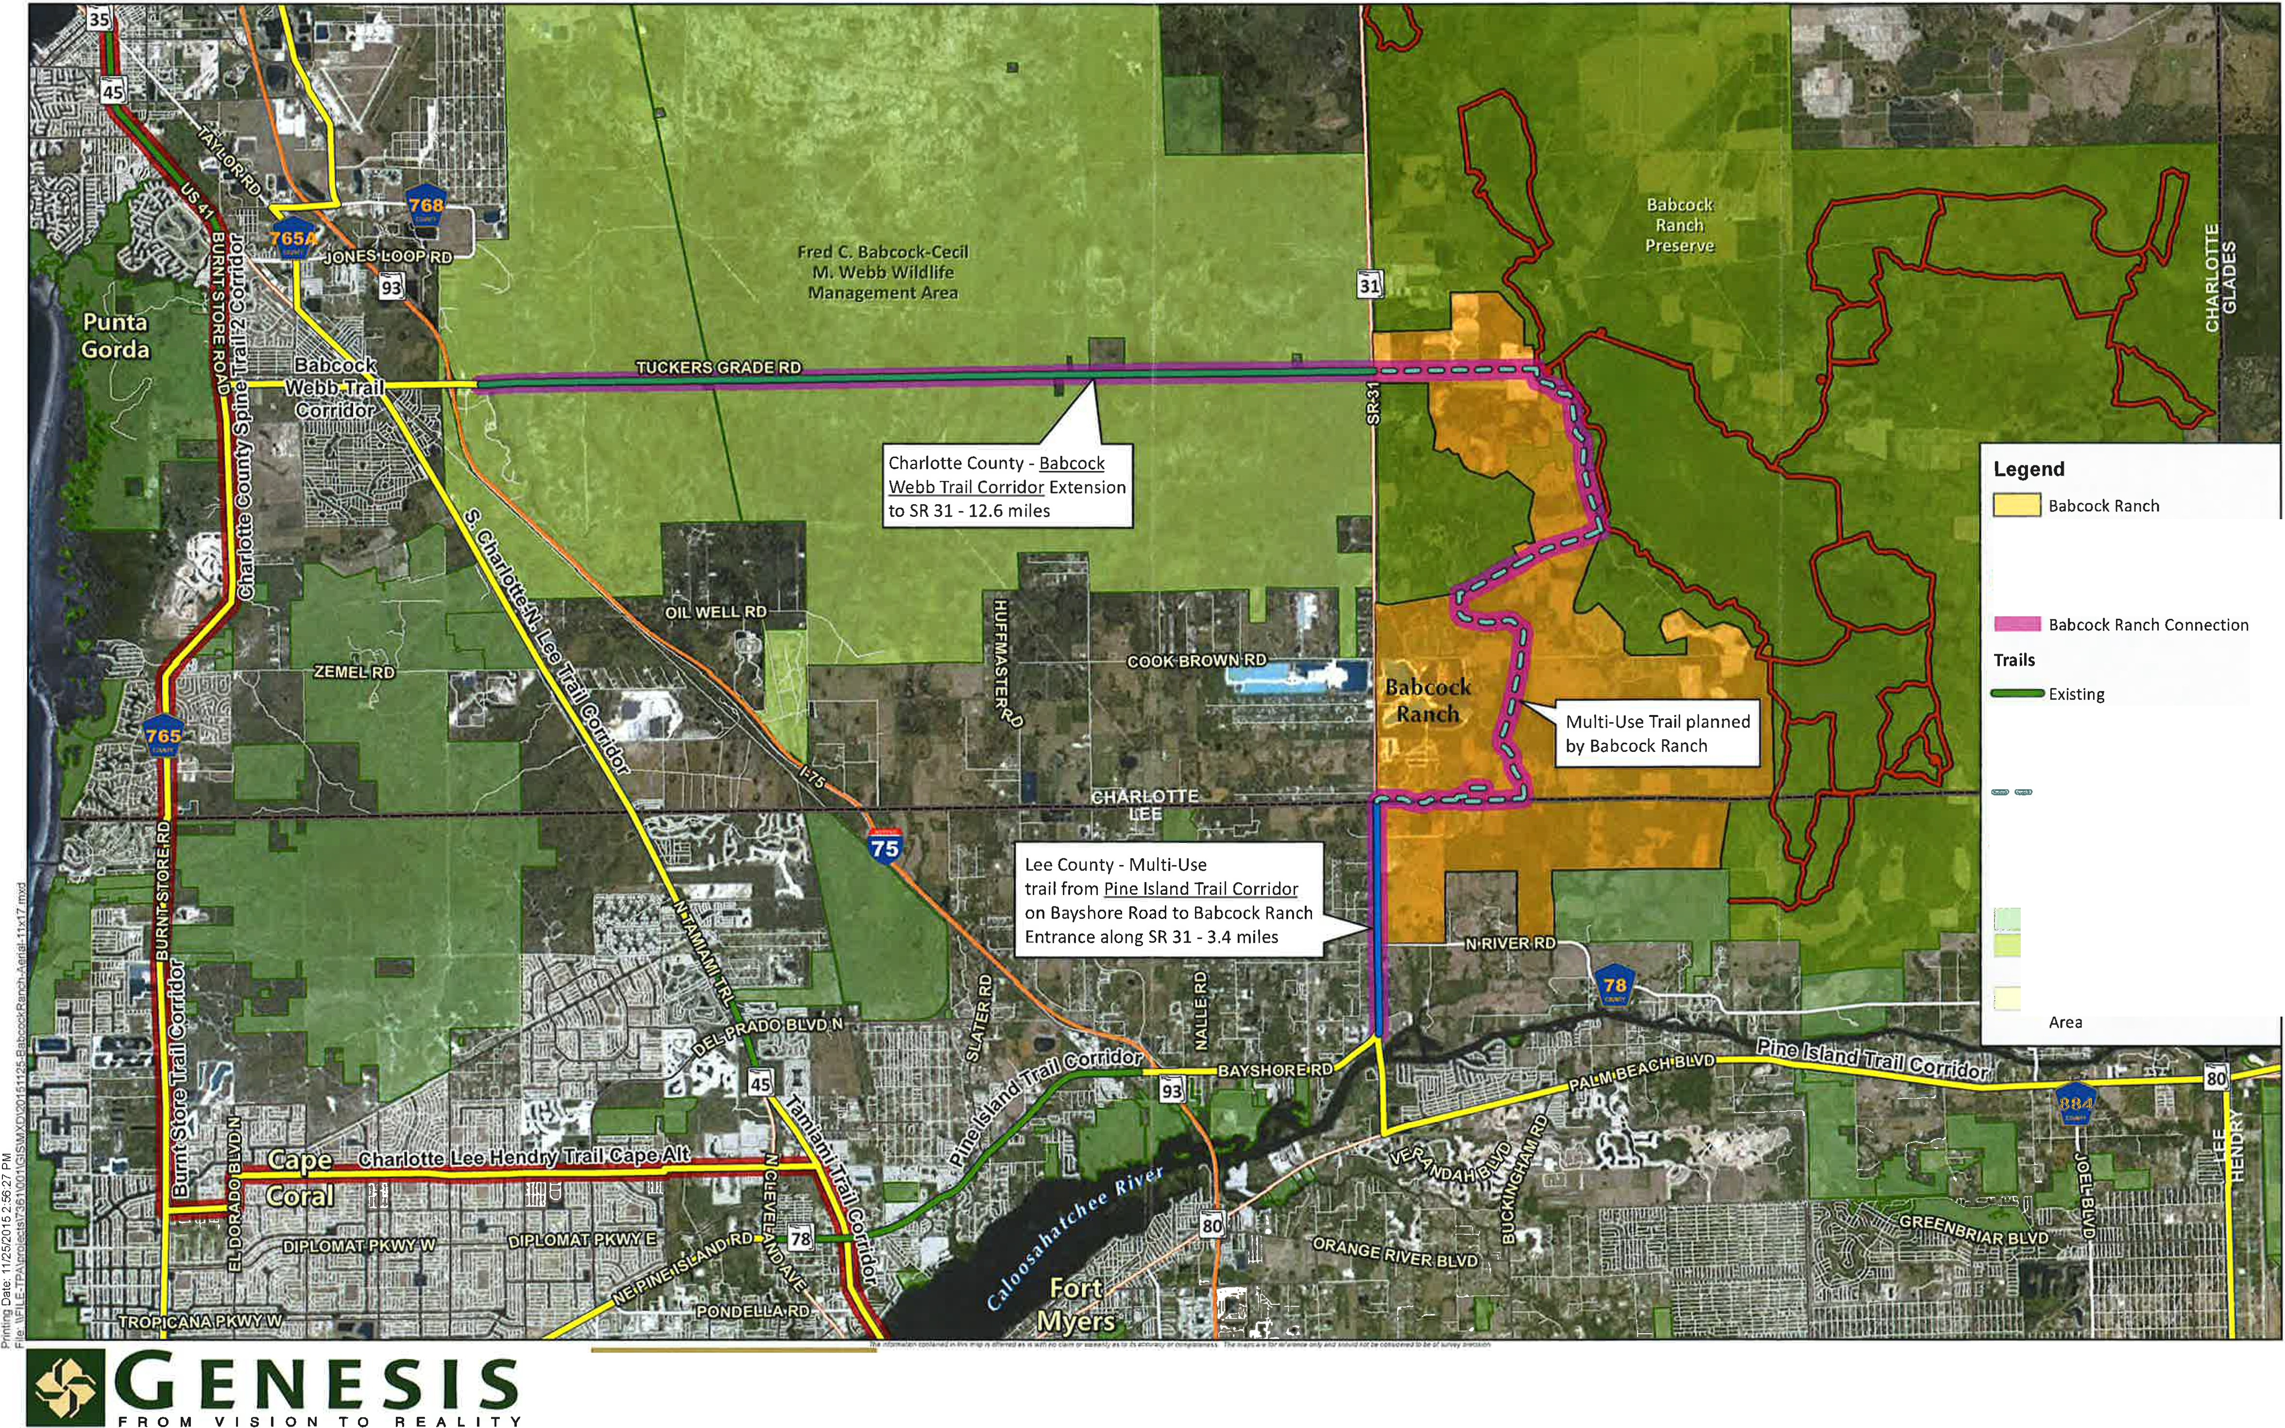
Engineering - Landscape Architecture - Planning - GIS
www.GenesisGroup.com

FL CA 00009660 FL LB 00 06816 FL LC 26000202

tial
l Connections
11/25/2015

Agenda Item 6 Joint Lee Charlotte County-Punta Gorda BPCC/BPAC 11/22/2016

BURNT STORE ROAD TRAIL AND CAPACITY IMPROVEMENT STATUS REPORT

Attachments: Map of Burnt Store Road Corridor in Charlotte and Lee County; Table and Map of Burnt Store Road Multi Use Trail Improvements from the Lee MPO Bike Ped Master Plan and 2040 Transportation Plan

Discussion Item: Existing commitment of funds towards Burnt Store Road
Capacity and Trail Improvements, and Future Bike Ped Needs along the Corridor

Background
Burnt Store Road is a north/south two-lane undivided rural roadway that runs from Pine Island Road in Lee County to US 41 in Charlotte County. Capacity improvements to the roadway were recommended in the Burnt Store Road-Veterans Parkway-Colonial Boulevard Bi-County Corridor Study that was completed in 2005. The study called for widening Burnt Store Road Corridor from two to four lanes from Pine Island Road (SR
78) to I-75 in Charlotte County. The corridor is identified as a critical evacuation route for both Charlotte County and the City of Cape Coral. The portion of the Burnt Store Road corridor from US 41 in Charlotte County to Van Buren Parkway in Lee County is part of the Southwest Coastal Connector aka Southwest Regional Trail, and lies within the FDOT’s SUN Trail Network thereby making this corridor eligible for SUN Trail funds.

Project Development - Lee County
The Lee County DOT has segmented the Burnt Store Road project into three different segments from Pine Island Road (SR 78) to Van Buren Parkway using local and Transportation Regional Incentive Program (TRIP) Funding. The Lee County South segment Burnt Store Road project is from Pine Island Road (SR 78) to Tropicana Parkway. Construction is programmed in the Lee County Transportation Improvement Program (TIP) for FY 2019/2020. The Central Burnt Store Road project is from Tropicana Parkway to Diplomat Parkway. Construction is programmed in the Lee County TIP for FY 2017/2018. The North Burnt Store Road project from Diplomat Parkway to Van Buren Parkway is under construction. All three segments include a multi-use trail on the east side, a sidewalk on the west side and bicycle lanes. The remainder of the Burnt Store Road project from Van Buren Parkway to the Charlotte County line is programmed for a Project Development & Environmental Study (PD&E) for FY 2019/2020. Both the Lee MPO 2040 Transportation Plan and the Countywide Bike Ped Master Plan identifies a shared use path/multi use trail on this segment.

Project Development - Charlotte County
In Charlotte County, capacity improvements on Burnt Store Road include the widening from 2 to 4 lanes from the Lee County line to US 41 and are divided into three phases.
Phases I and III, the four-laning segments of Burnt Store Road are existing from the Lee County Line to a point just north of Zemel Road (Phase III) and from just south of Notre Dame Blvd. to US 41 (Phase I). Both segments include paved shoulders and 6’ wide sidewalks. Sixty percent of the design and ROW acquisition is under way for the remaining segment (Phase II) from just north of Zemel Road to just south of Notre Dame

Blvd, with construction anticipated to commence by end of 2017. The current design includes paved shoulders and 6’ wide sidewalks. Charlotte County Public Works has now informed MPO staff they will build undesignated bike lanes instead with bicycle keyholes next to right turn lanes. They will also evaluate the viability of a shared use path on the east side, and will report their findings at the November 22nd BPCC meeting.

The section of North Jones Loop Road from US 41 to Piper Road is also part of the Corridor Study as it connects the Corridor to I-75 and Piper Road. The six-laning of the North Jones Loop Road section is in the Charlotte County-Punta Gorda MPO’s TIP for a PD&E in FY 2019/2020. Multi-Use Trail and bicycle lanes will be considered in the study.

Recommendation from the April 12, 2012 Joint Lee/Charlotte-Punta Gorda MPO meeting Both Lee and Charlotte County-Punta Gorda MPO agreed at their April 12, 2012 joint meeting that the Burnt Store Road corridor is a regional road that is critical to evacuation efforts for Lee and Charlotte Counties. They recognized that both Counties identified funds to complete significant segments of the roadway expansion in the corridor and that more remains to be done. The MPO Boards have agreed to complete the needed improvements through submission of Joint TRIP project priorities to FDOT annually until all segments of the roadway were completed. FDOT should continue to work with the respective County, City and MPO staffs to complete all segments.

Burnt Store Road

Burnt Store Rd – Charlotte County
Burnt Store Rd – Lee County

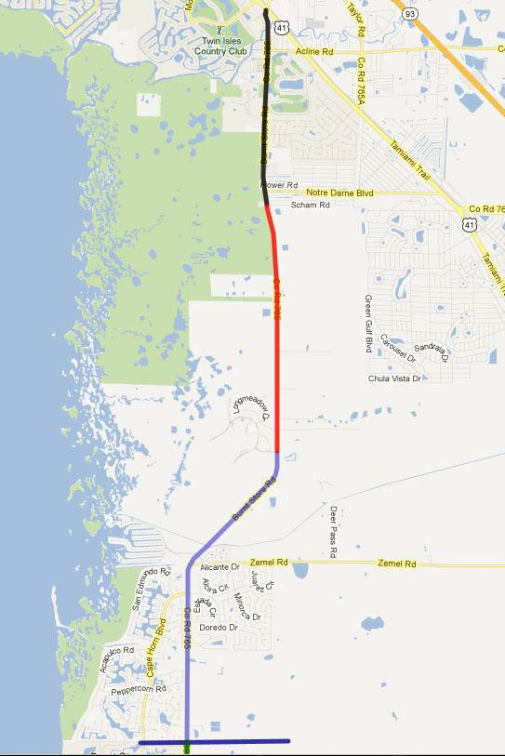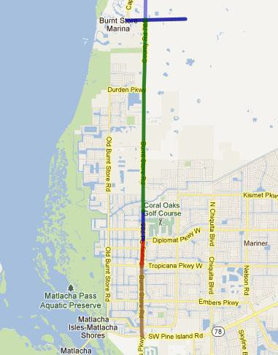
Phase I – Completed
Scham Rd to US 41
Phase II –
Design Complete Feb 2017
CST – Oct 2017
South of Tern Bay Blvd to Scham Rd
County line
Phase III- Completed
Lee County Line to South of Tern Bay Blvd
County Line
PD&E 2019/2020
Van Buren Parkway to County Line
North Segment
Under Construction Diplomat Parkway to Van Buren Parkway
Central Segment
CST 16/17
Tropicana Parkway to Diplomat Parkway
South Segment – Local CST 2018/19
Pine Island Road to Tropicana Parkway

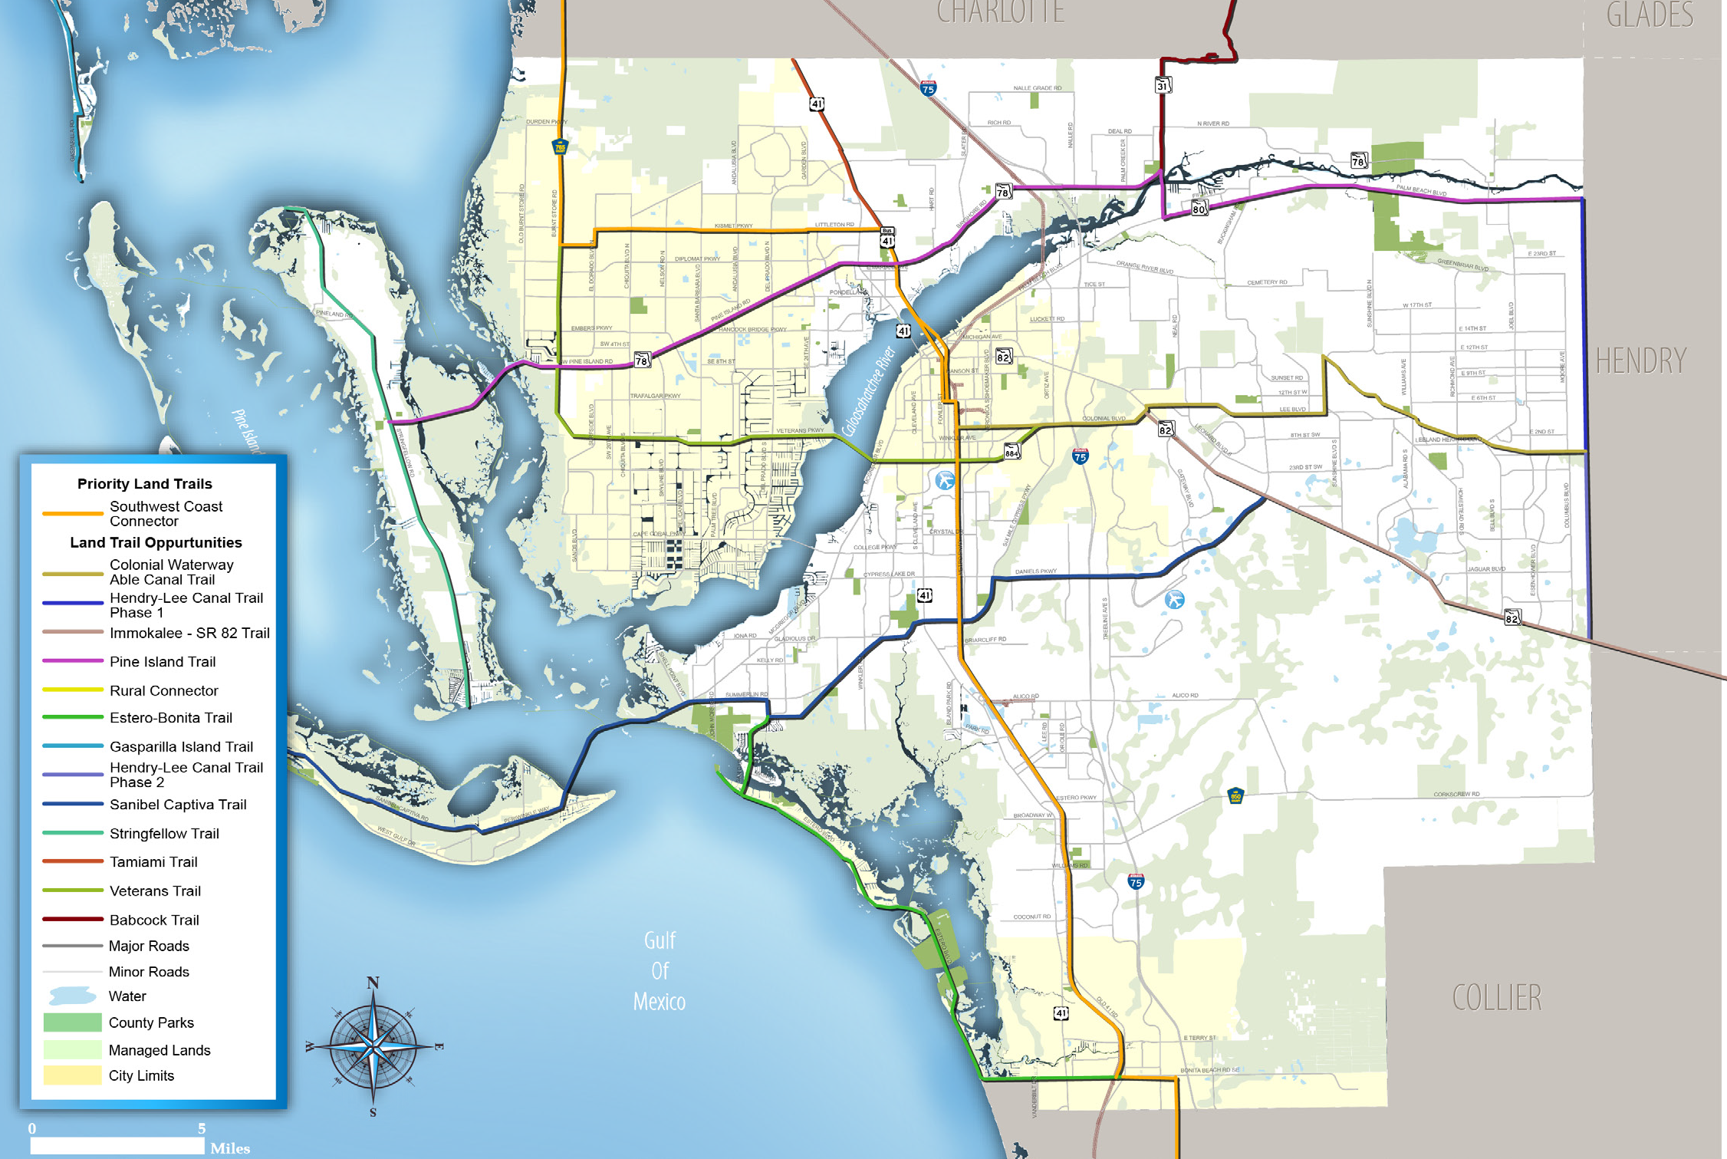FIgure 4: Lee County Portion of Florida Greenways & Trails System Land Trails Opportunities Map

Note: The MPO will request that the Babcock Ranch Trail is added to the Florida Greenways and Trails System Maps when the Florida Department of Environ- mental Proection updates the maps in 2018.

12 | LEE COUNTY MPO Bicycle and Pedestrian Element

Exhibit BBB Prioritized Needs Plan
LEE COUNTY MPO BICYCLE PEDESTRIAN MASTER

PROJ NO.

IN FIN
FEAS ROADNAME

LENGTH
(FT) FROM TO JURISDICTION

IMPROVE. TYPE

TOTAL
SCORE SAFETY

CONNECT- IVITY

MOBIL- ITY

ECO- NOMIC

FEASIBIL- ITY

COST/ FT
SIDE OF ROAD

TOTAL
COST UNFUNDED FUNDED

- OLD 41 RD 1,108 S TAMIAMI TRL STRIKE LN BONITA SPRINGS SIDEWALK 10 2 2 3 3 0 $40 1 $44,302 $44,302 $0

- STRINGFELLOW RD 2,334 YORK RD SANIBEL BLVD COUNTY SIDEWALK 10 2 2 3 3 0 $40 2 $186,718 $186,718 $0

- OLD 41 RD 792 N TAMIAMI TRL SAN SOUCI DR STATE SHARED-USE
10 | 2 | 2 | 3 | 3 | 0 | $60 | 2 | $95,046 | $95,046 | $0
10 | 3 | 2 | 3 | 2 | 0 | $60 | 1 | $26,260 | $26,260 | $0
10 | 3 | 2 | 2 | 3 | 0 | $60 | 2 | $236,926 | $236,926 | $0

PATH

- PALM BEACH BLVD

- PALM BEACH BLVD

438 CARTAGENA AVE LORING WAY STATE SHARED-USE PATH

1,974 MORSE PLAZA I-75 STATE SHARED-USE PATH

- Y BURNT STORE RD 46,249 COUNTY LINE CEITUS PKWY COUNTY SHARED-USE
PATH

10 2 3 3 2 0 $60 2 $5,549,877 $0 $5,549,877

82 BELL BLVD S 25,496 JOEL BLVD SR 82 COUNTY BIKE LANE 10 3 2 3 2 0 $27 2 $1,376,787 $1,376,787 $0

- CAPE CORAL PKWY W 8,162 SANDS BLVD CHIQUITA BLVD CAPE CORAL BIKE LANE 10 2 3 3 2 0 $27 2 $440,770 $440,770 $0

- NORTH RIVER RD 63,000 BAYSHORE RD JOEL BLVD COUNTY BIKE LANE 10 2 3 3 2 0 $27 2 $3,402,000 $3,402,000 $0

- SAN CARLOS BLVD

- CAPE CORAL BRIDGE
5,824 S TAMIAMI TRL LEE RD COUNTY BIKE LANE 10 2 3 3 2 0 $27 2 $314,469 $314,469 $0

SHARED-USE

RD 1,724 WAIKIKI AVE BRIDGE COUNTY PATH 10 3 2 3 2 0 $60 2 $206,891 $206,891 $0

- VETERANS PKWY 605 SW 11TH AVE SKYLINE BLVD COUNTY SHARED-USE
PATH

- TREELINE AVE 3,363 COLONIAL BLVD PELICAN PRESERVE BLVD COUNTY SHARED-USE
PATH

9 2 2 3 2 0 $60 1 $36,309 $36,309 $0

9 2 2 3 2 0 $60 1 $201,776 $201,776 $0

89 BELL BLVD S 26,454 JOEL BLVD SR 82 COUNTY SIDEWALK 9 3 2 3 1 0 $40 2 $2,116,290 $2,116,290 $0

- SANDS BLVD 3,831 BEACH PKWY W CAPE CORAL PKWY CAPE CORAL SIDEWALK 9 1 2 3 3 0 $40 2 $306,471 $306,471 $0

- Y SR 82 74,932 COLONIAL BLVD COUNTY LINE STATE SHARED-USE
PATH

9 1 3 3 2 0 $60 2 $8,991,893 $0 $8,991,893

- CAPE CORAL PKWY W 4,751 SAND BLVD AGUALINDA BLVD CAPE CORAL SIDEWALK 9 1 2 3 3 0 $40 2 $380,071 $380,071 $0

- JOEL BLVD 30,293 PALM BEACH BLVD E 6TH ST COUNTY SIDEWALK 9 1 3 3 2 0 $40 2 $2,423,442 $2,423,442 $0

- JOEL BLVD 8,033 PALM BEACH BLVD TUCKAHOE RD COUNTY BIKE LANE 9 1 3 3 2 0 $27 2 $433,771 $433,771 $0

- JOEL BLVD 25,379 E 18TH ST LEELAND HEIGHTS BLVD COUNTY BIKE LANE 9 2 2 3 2 0 $27 2 $1,370,482 $1,370,482 $0

- CAPE CORAL PKWY E 546 SANTA BARBARA BLVD SE 1ST PL CAPE CORAL BIKE LANE 9 2 2 3 2 0 $27 2 $29,467 $29,467 $0

- Y BUCKINGHAM RD 28,899 PALM BEACH BLVD GUNNERY RD COUNTY BIKE LANE 9 2 2 3 2 0 $27 2 $1,560,534 $0 $1,560,534

- ORANGE RIVER BLVD
10,645 PALM BEACH BLVD FPL ACCESS RD COUNTY SHARED-USE
PATH

9 2 2 3 2 0 $60 2 $1,277,379 $1,277,379 $0

- ORANGE RIVER BLVD 10,645 PALM BEACH BLVD FPL ACCESS RD COUNTY BIKE LANE 9 2 2 3 2 0 $27 2 $574,820 $574,820 $0

SHARED-USE
- E TERRY ST 4,722 SOUTHERN PINES DR BONITA GRANDE DR BONITA SPRINGS PATH 8 0 3 3 2 0 $60 2 $566,621 $566,621 $0

Agenda Item 7 Joint Lee Charlotte County-Punta Gorda BPCC/BPAC 11/22/16

PRESENTATION ON THE TIGER FUNDED LEE COUNTY COMPLETE STREETS INITIATIVE

Attachments: Map of Proposed TIGER funded Improvements

Information Item: Background, Status Update and Project Takeaways

The Lee County MPO received a TIGER Grant for $10.4 million in 2014 for undertaking the Lee County Complete Streets Initiative project. The project includes construction of shared use paths, bike lanes, sidewalks, paved shoulders, bus shelters, and wayfinding signs at various locations within Lee County. These locations are primarily along the Lee County’s premier Tour De Parks Route and the University Loop Route. See attached location map. Most of the improvements under this project have now been completed.

At the November 22nd BPCC meeting, Lee MPO staff will provide a presentation including background of the project, status of the individual sub-projects, and the major takeaways from undertaking such a project.

Alabama

Georgia

G U L F O F M E X I C O

LEE COUNTY

Florida

A
RD SLAND
PINEI
B Fort

75
LEE COUNTY COMPLETE STREETS INITIATIVE
TIGER Grant Application 2013

Legend

Myers
North Colonial
Linear
Existing Complete Streets

Cape Coral

CAPE CORAL PKWY

VETERANS PKWY
Lee Memorial
Hospital

E D
COLONIAL BLVD
F
G
H
Park C

Hodges Univ.

1
(outside project area)
Parks
City Limits University/College Hospital

Points of Interest

Six Mile Cypress

Edison I State College

Lakes Regional Park
SAN CARLOS BLVD
Gulf Coast Hospital

L
J K
Slough Park

N

O P
M

Southwest Florida International Airport
- Downtown Fort Myers River District
- Edison Home
- Lee County Nature Center
- Lee County School Administration Center
- Edison Mall
AA

Z

G U L F O F M E X I C O
T Q

2
R
Three Oaks Park

S
Koreshan State Park
U
ALICO RD

Florida Gulf Coast University
- Page Field
- Chico’s Headquarters
- John Yarbrough Linear Park Trail
- Barbara Mann Performing Arts Center
- Lee County Sheriff’s Ofﬁce
- Lee County Sports Complex/ Minnesota Twins Stadium
- Daniel’s Crossing
- Red Sox Stadium/

1 Tour de Parks Loop
Existing Complete Streets
Proposed TIGER-funded Project
Proposed TIGER-funded Intersection Improvement

2 University Loop
Existing Complete Streets
Proposed TIGER-funded Project

3 Bi-County Connector
Existing Complete Streets Proposed TIGER-funded Project Proposed TIGER-funded Bus Stop
3 75

Future Estero Hospital
Bonita

V Springs

X W

North Naples Hospital
Transfer
Y Station
Minnesota Twins Spring Training Facility
- Daniels/ I-75 Commerce Center
- Southwest International Commerce Park
- Arlington Commerce Park
- Florida Gulf Coast Research Park
- Gulf Coast Town Center
- Germain Arena
- Alico Road Industrial Park
- Future Hertz HQ
- Bernwood Business Park
- Naples Fort Myers Greyhound Track

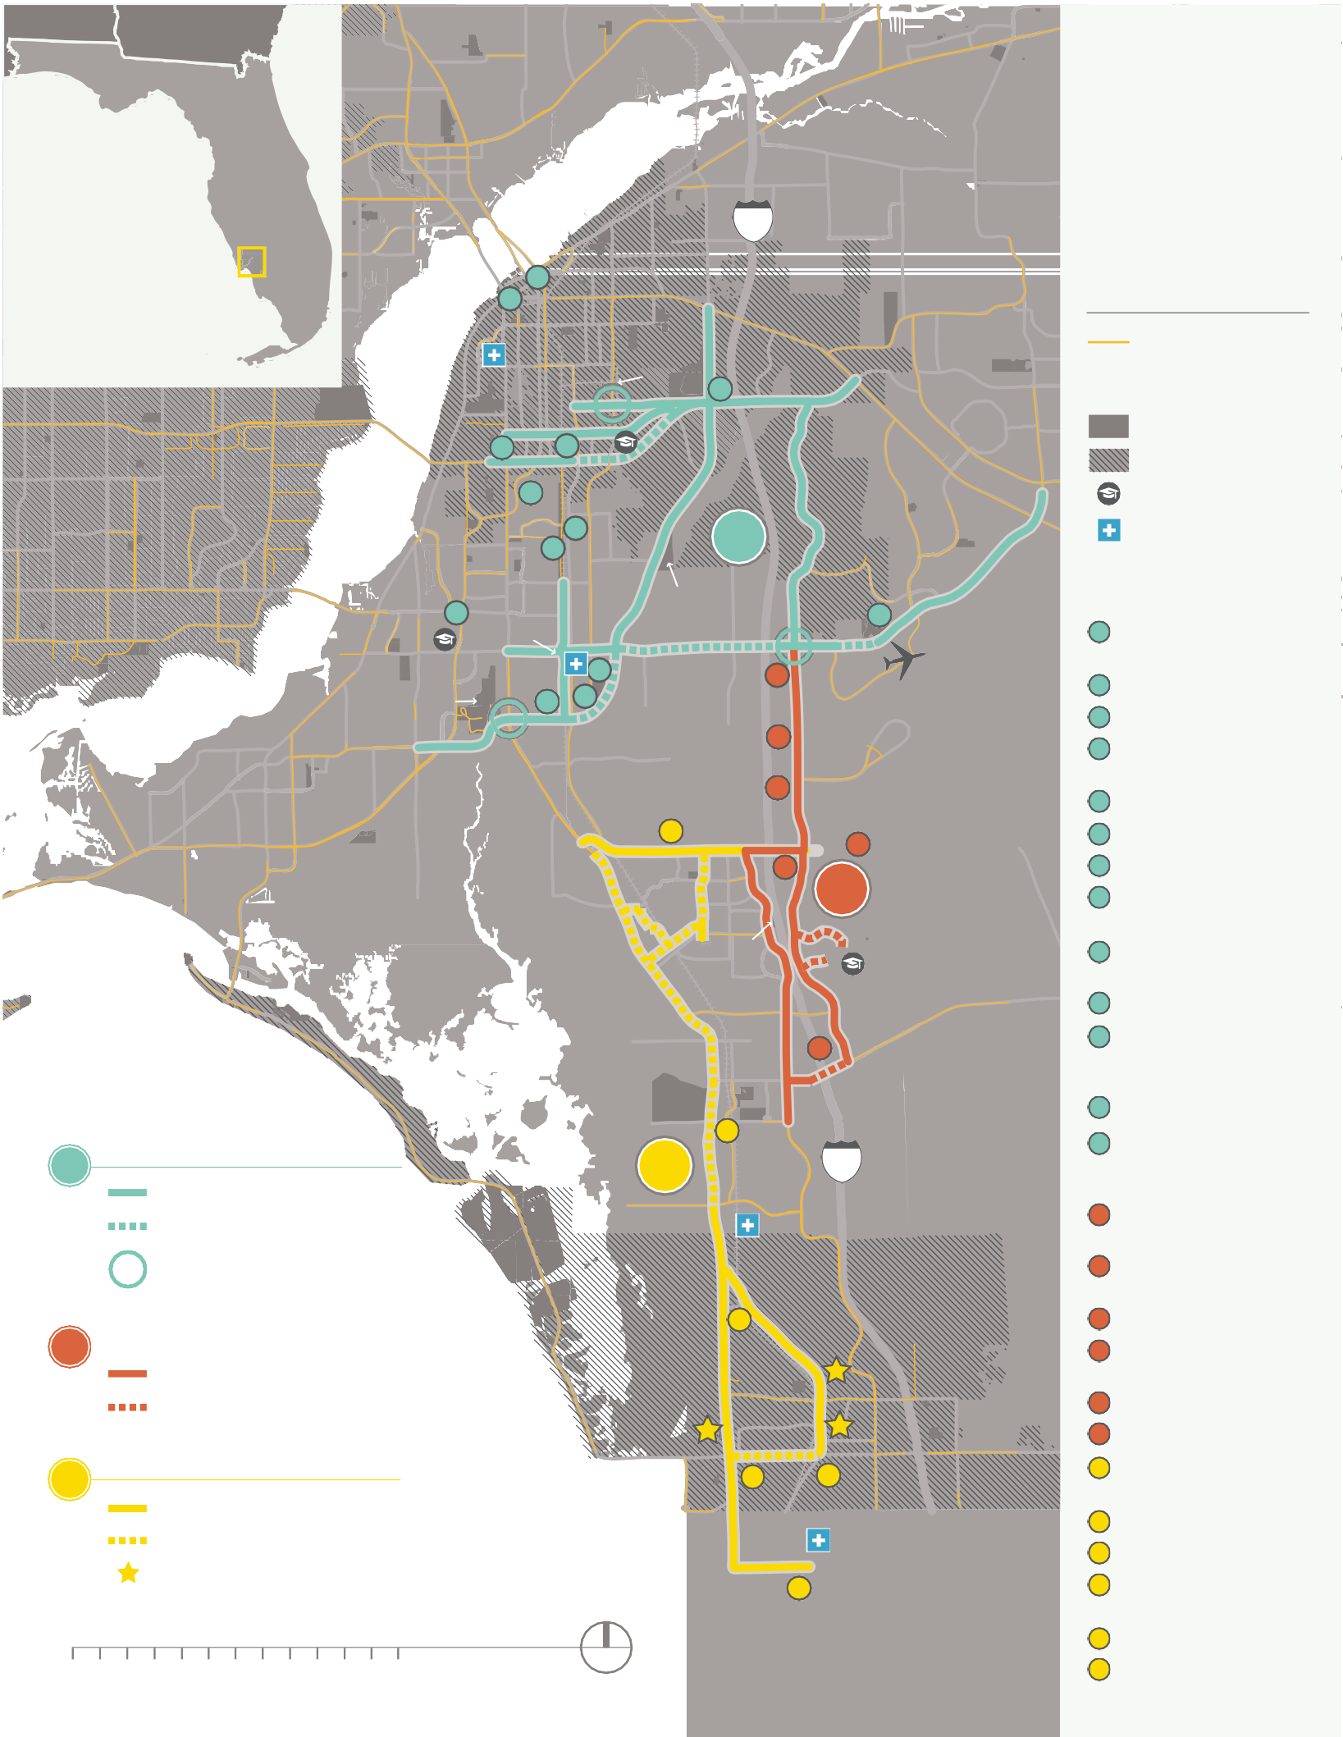MILES

0 2 4 6
N
- Bonita City Hall
- Creekside Business Park

Agenda Item 8 Joint Lee Charlotte County-Punta Gorda MPO 11/22/2016

PRESENTATION ON THE CITY OF PUNTA GORDA BIKE SHARING PROGRAM

Attachments: Bike Map to be provided at meeting

Information Item: Presentation on the City of Punta Gorda’s Bike Sharing
Program

Following the devastation of Hurricane Charley in 2004, a group of citizens launched TEAM Punta Gorda, a citizen’s action organization whose mission was to facilitate the development and implementation of a master plan for Punta Gorda’s recovery. The master plan provided guidance and direction as numerous projects took shape in our community. Today, one of the TEAM’s projects in collaboration with the City of Punta Gorda and other community organizations continue to foster healthy growth and development. The Bicycle loaner program, in partnership with the City of Punta Gorda and supported by local businesses and private individuals, was initiated in 2010. Last year, the service provided bikes for more than 5,000 riders from 43 states, five provinces of Canada and 14 countries who explored miles of bike paths in and around the City. There are now 44 bikes available at six locations.

